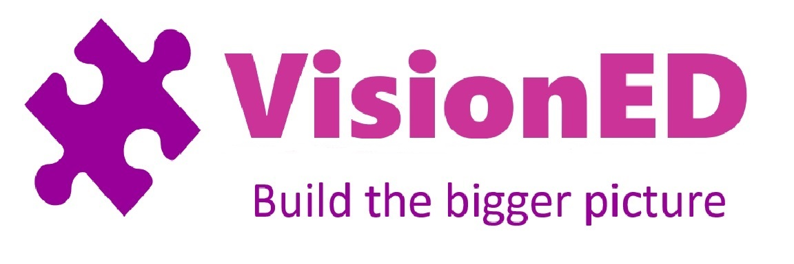
Gymnastic Resource Cards
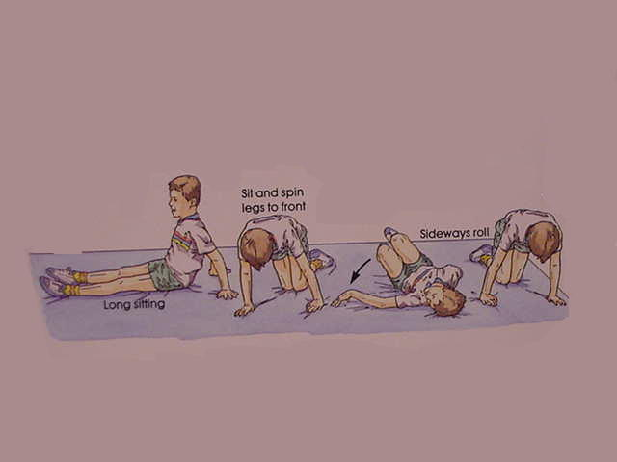
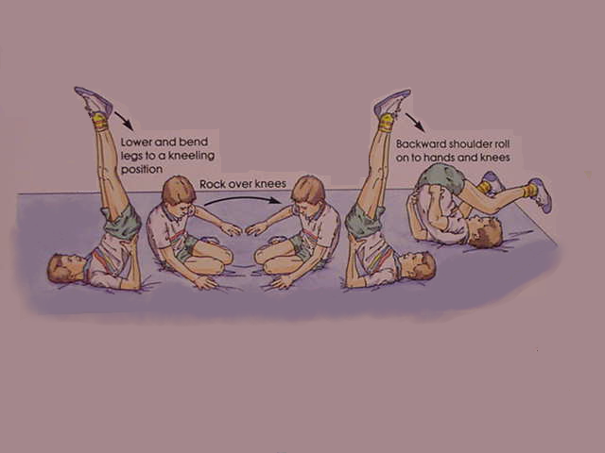
Sequences
Possible Extension work would be to try and complete the sequence, with minor adaptations in the reverse direction.
Quality:
Try to keep good body tension throughout.
Legs should be straight, knees together and toes pointed at positions 1, 2 and 3.
A short sequence involving rolling and balances
1
2
3

