
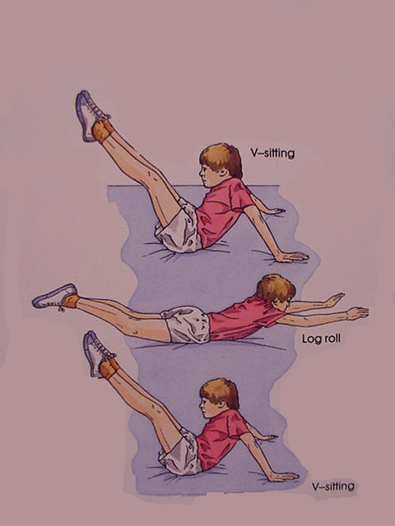
Gymnastic Resource Cards
Rolling
A simple individual rolling action
Top Tip!
Keep your legs tense and tight to make the movement easier

