
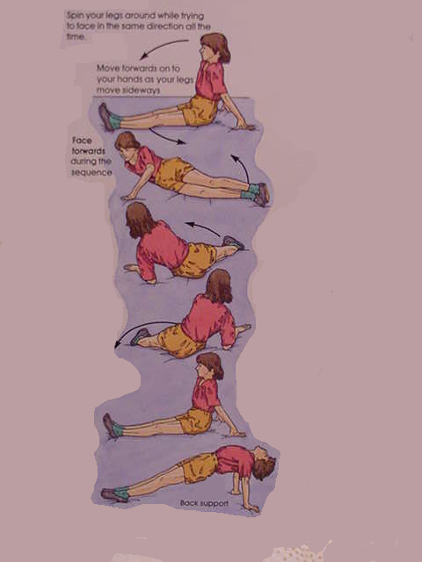
Gymnastic Resource Cards
Sequencing
A simple short individual sequence
Top Tip!
Keep your legs tense and tight together to make the leg swing easier

