Name | Challenge 1 | Challenge 2 | Challenge 3 | Challenge 4 | Total
 | Hoop Bounce | Dribble Run | Chest Pass | Set Shot
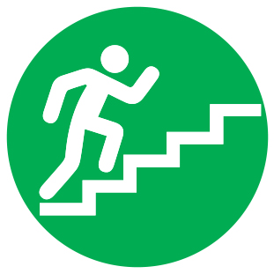
Basketball Challenge KS1

