
Gymnastic Resource Cards

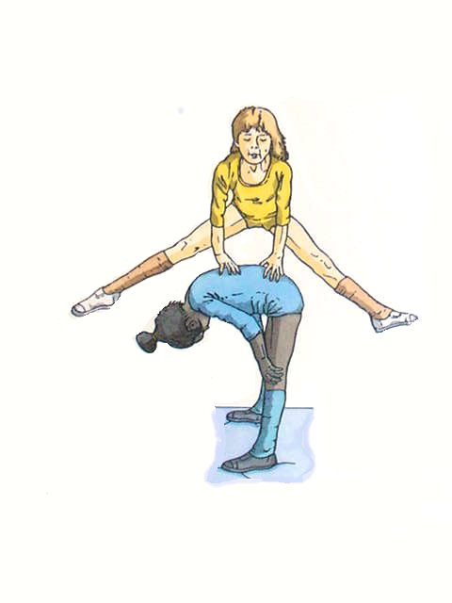
Basic Vaulting – Leap frog
Key Point
- Place your hands flat on the back
- Keep looking forward
- Bounce and take off from two feet
- Tense your legs wide

Base:
- Tuck head in
- Hold knees
- Good strong position
Keep looking forward NEVER down
Base:
Keep your head tucked in

