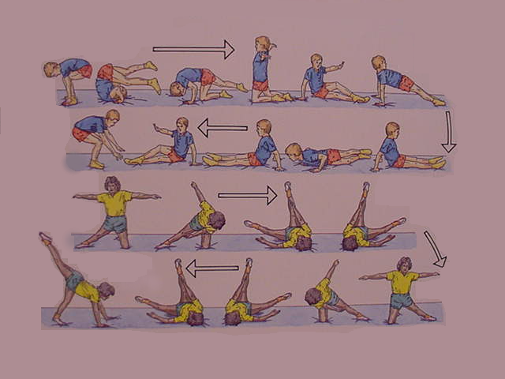
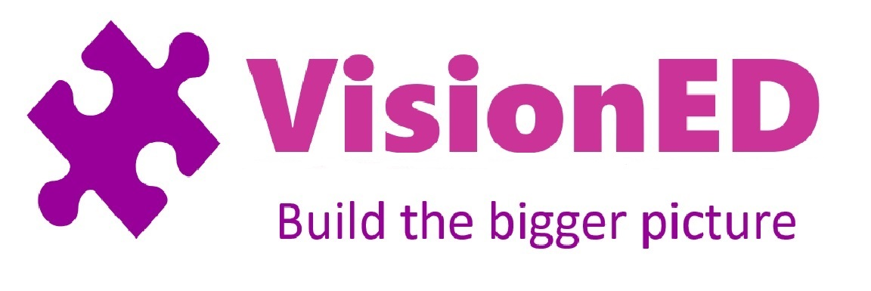
Gymnastic Resource Cards
Possible Extension work would be to try and complete the sequence, with minor adaptations in the reverse direction.
Two short sequences involving rolling and balances
1
2
3
Sequencing
4

Balance Points are marked with a yellow box. Hold these for three seconds at points 1, 2, 3 and 4

