Primary Summer Panathlon
Murray Movement | Tennis
Rugby | Long Jump
Direct Hit | Football
Parachute | Shuttle Run

Thank you for electing to take part in the primary summer multi-skills. This pack contains: rules, results templates for internal use, video clips and monitoring forms.

Summer multi-skills enables competitors can take part in a series of activities across several weeks or sessions. Individual schools can select their own activities based upon their own judgements regarding facilities, zones, teaching bubbles, equipment, time allocated, current national guidelines, school policies and risk assessments.

General Guidelines
- Activities can be run by the class teacher or with the help of additional leaders/helpers.
- Teachers will need to select their own team ‘micro bubble’ sizes based upon their risk assessments.
- Each ‘micro bubble/team’ will move to each activity via set ‘zones’ in accordance with school policy.
- Schools can select activities from the menu and decide upon their own length of time to complete the activities i.e. 5 minutes per activity or a set number of goes (based on individuals or equal size teams).
- Mainstream students can work alongside SEN students to enable the activities to take place then score the SEN competitor as an individual.
- Schools can choose to record team/ bubble or individual scores and opt to produce their own school rankings for internal use.

Equipment Guidelines
- Where possible, one piece of equipment each, rather than shared.
- Ensure that equipment is safe after each activity to stop slips and trips when rotating to each zone.

To receive certificates, send a completed monitoring form to entries@panathlon.com

Murray Movement
Video Link: https://youtu.be/GRjq11aQ4t0

Equipment
- Bean bag (ball, or rolled up socks),
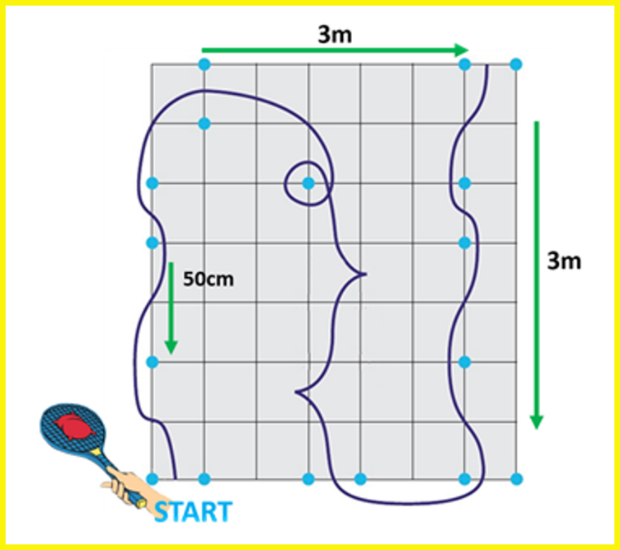
- Tennis racket (or badminton),
- 17 x cones.
- Stopwatch

Set-up
- Cones are set out 50cm apart (measured from end of cone)
- with chalk or floor markings showing the direction. 3.5m x 3.5m

Aim ‘Complete a slalom course around the cones.’
- Balance a bean bag on a tennis racket. Team members take it in turns.
- Activity can be varied using a football or hockey sticks to dribble.

Scoring

- Team: Number of completed slaloms, in 5 minutes

- Individual: Two attempts. Add times together.

Adaptations
- VI: Competitors can follow a guide.
- HI: Visual cues can be given to start the slalom, e.g., lower an arm to start.
- Wheelchair users: Self-propel on a wider course or be pushed.
Can carry the beanbag without a racket, if required.

Rugby: Zig Zag Try

Equipment
- Rugby ball or another soft ball that you can hold.
- 8 cones
- Stopwatch

Set up
- Cones are set up per diagram as a zig zag.
- From a start cone, place 4 cones ( one metre to the left of the player) in a straight line at (2m, 4m, 6m & 8m)
- From a start cone, place 4 cones ( one metre to the right of the player) in a straight line at (3m, 5m, 7m & 9m)
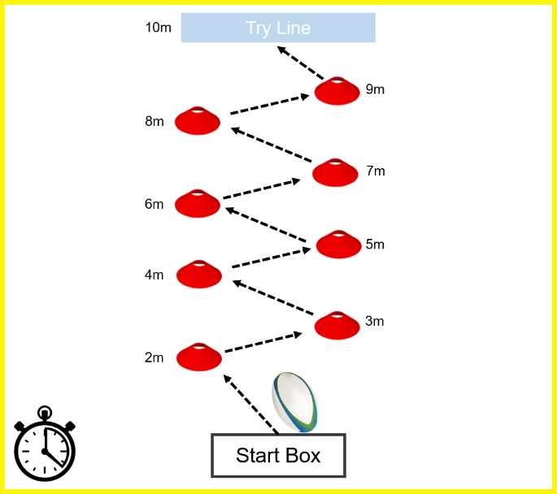
- Try line at 10m.

Aim ‘Run and touch down for a try.’
- Line the team 1 metre back in a safe zone away from the start cone
- From the start cone, pick up the ball and run through the zig zag course starting with the nearest cone on the left.
- Complete the course through the cones and score a ‘try’ by touching the ball down with both hands on the ground.
- The ball must be held in two hands through the cones.
- After the ‘try’ run back with the ball and place in the start box ready for the next player.
- Next player can only start when the previous player has joined the end of the line.

Scoring
- Team Total number of times the children complete the course in the allocated time.
- Individual Two attempts and the times are added together. If the ball is dropped, 5 seconds added on to the final time.
Adaptations
- VI: Competitors can follow a guide.
- HI: Visual cues can be given to start the slalom, e.g., lower an arm to start.
- Wheelchair users: Self-propel on a wider course or be pushed.
Direct Hit
Video clip - https://youtu.be/tUgXuDH47kg

Equipment: 1 ball per person (bean bag), set of stumps (skittles/cardboard tubes or equivalent) 1 x cone
Set-up
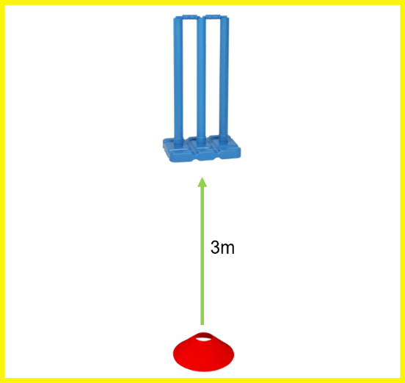
- Place one set of stumps/skittles 3 metres from a throw line.
Aim ‘Hit the stumps’

- A continuous team relay that gets more difficult.’ (aim at the stumps for points - take stumps away!)
- 1st round: The first competitor stands at the cone and rolls/underarm throws the ball towards the stumps, collect their ball, join the end of the queue. The next competitor takes their turn until everyone has had one attempt.
- 2nd round: Take the stump away leaving two. (Select a designated person to remove stumps)
- 3rd round: Take one stump away leaving one.
- NOTE: The next competitor does not throw until the previous player has collected their ball & rejoined the queue.
- After 3rd round, re-start the game for a second attempt to beat the score.

Scoring
- 1st round: 1 point, if any of the 3 stumps are hit.
- 2nd round: 2 points, if any of the 2 stumps are hit. (If unable to take away stumps-aim for outside stumps)
- 3rd round: 3 points, if the final stump is hit. (If unable to take away stumps-aim for middle stump)
- No points if the ball hits the base only, rather than a stump.
Team Add every score to give the team/bubble total, within 5 minutes if timing or two full rounds.
Individual Two full rounds (3/2/1 stump) – add scores together (1+2+3+0+0+3=9)
Adaptations
- VI: Leader/helper can clap near the stumps.
- Bell balls can create audio cue.
- Wheelchair users take their shots closer or use ramps to propel the ball.
Parachute Popcorn

Equipment

- 1 x Parachute, six blue, red, yellow and green playballs – 24 in total
- Box or bucket for ball collection
- Stopwatch

Set-up
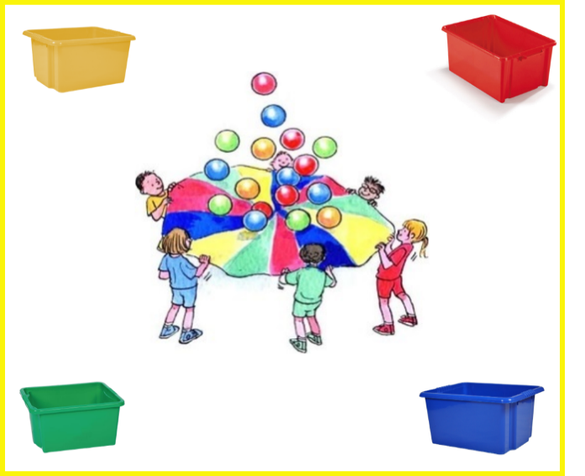
- Competitors stand spread out around the outside of the parachute lifting the parachute up which contain six blue, red, yellow and green playballs 24 in total.
Aim ‘ Collect the balls and place in the containers.’
- Shake the balls so that they fly off the parachute,
- The helper will then then say ‘GO’ which starts the stopwatch.
- Players start collect the balls ensuring that they are placed in the corresponding, coloured container.
- The stopwatch will stop when all the balls have been collected in the correct container.
- Competitors are only allowed to pick up one ball at a time.
Scoring
- Team: The time is recorded when 24 balls are placed in the correct coloured collectors e.g. 6 red/6 blue/6 yellow/6 green. Teams may have two attempts, to achieve their best time. The best time is then recorded.
- Individual: With helpers holding the parachute- time the individual collecting 6 balls, then repeat for a second attempt

Adaptations
- VI: Can follow a leader or use a guide as assistance.
- HI: A visual cue can be given by the leader to start, as well as audio. eg, lower an arm to start.
- Wheelchair users: Can be pushed.
- PD & LD with balance difficulties: can have support from an adult. Children can walk from number to number.

Rally Tennis

Video Clip: https://youtu.be/FZ4dT48kZ2o
Equipment
Ball, tennis racket or equivalent per child, tape. (rackets to be wiped after each go)

Set-up
Mark out the court area with tape. Use half a badminton court in width or (2m width) length 6 m (no net)

Aim ‘ Count the rally’
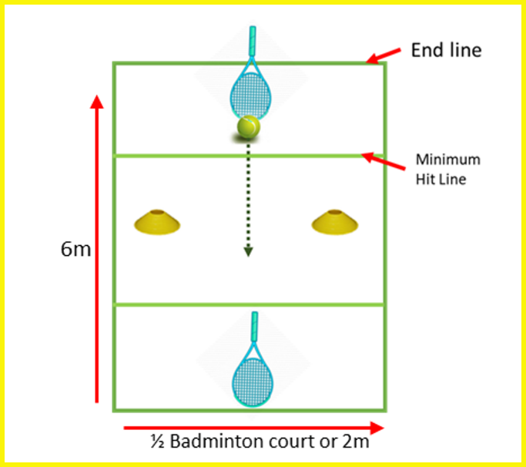
Two competitors stand and aim to push/roll the ball in a continuous rally on a small court between two cones.
The ball must go past the minimum hit line (2m)

The rally ends when:
- The ball lifts from the floor
- The ball goes past the end line
- The ball hits a player’s body, including hand
- The ball does not pass between the cones
- The ball is hit inside the minimum hit line
- The ball stops within the minimum hit line

Rotate each pair after each rally ends (Max rally 30 secs)

Scoring

- Team: The highest rally for the team is recorded
- Individual: Highest score with a partner

Adaptations
- Bell balls can aid VI players.
- Wheelchair users can use their chair to stop the ball, this does not affect rally count (side on using the big wheel, taking extra care when pushing from backwards to forwards),
- Wheelchair users could also use a cricket bat/hockey stick if unable to reach to the floor, but ball must still stay along floor.

Athletics- Long Jump
Equipment
Long jump mat/gym mats with a tape measure, speed bounce mat or line on floor.
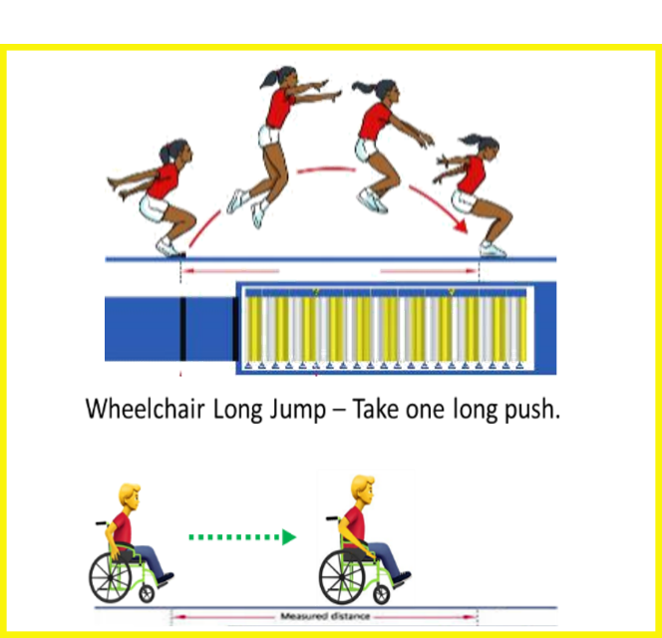
Set-up
Place mats as per diagram.
Standing Long Jump

Requires designated person to measure and record.

Aim Three jumps per competitor.
- Two footed take off from a standing position with both feet behind the take off-line
- The participant may step forward after the jump however any step back or touching of the mat or floor behind the feet is a no jump (x)

Scoring
- Measurement is taken from the back heel back to the take off-line
- A valid jump is recorded if both the athlete’s feet land on any part of the mat.
- When each competitor has completed their 3 goes.

Team: The two highest individual jumps and two lowest individual jumps will be added together to give an overall long jump score.
Individual: The highest two scores added together.

Adaptations
- Wheelchair user- one push and distance is measured.

Football: Dribbling Weave

Video Link: https://youtu.be/tOynyGXsAHo

Equipment
- 1 x Football
- 6 x Cones, to weave around.
- 2 x Further Cones, for start/finish (Tape, Chalk, Grass Marking Paint, Floor Line)

Set up
- Start/Finish line is 1m from the first cone. Place 6 cones 1m apart in a straight line.
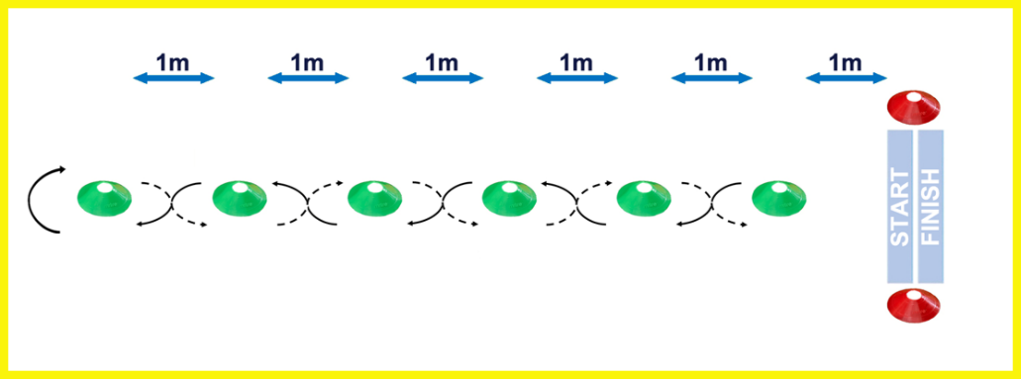
Aim “Dribble a football between cones, there & back”
- 1 player at a time.
- Start and finish in the same place.
- Continuous relay for 5 minutes.
- Ask the player to stop the ball on the Start Line for the next player (rather than pass).

Scoring
- 2 points are scored for successfully weaving ‘up’ between all the cones
- 2 points are scored for successfully weaving ‘down’ between all the cones, back to the start line.
- 1 point is awarded for weaving ‘up’ or ‘down’ if any weaves are missed or cones are hit by the ball.
- A maximum of 4 points and minimum of 2 points can be scored in any players attempt.

Team: Total number of points scored, within 5 minutes or (3 goes each based on equal team sizes)

Individual: Player has 3 goes (there and back) and adds all their scores together. Each go can be taken with a rest in between, if required.

Adaptations
- To simplify take away every other cone.
- VI: A bell ball will create an audio cue to aid direction of the ball. Leader/helper can clap in direction of cones.
- HI: A paddle will give a visual cue to signal when to start.
- Wheelchair users: Can carry the ball on their lap around the course.

Shuttle Run

Equipment

- 4 x Large Cones
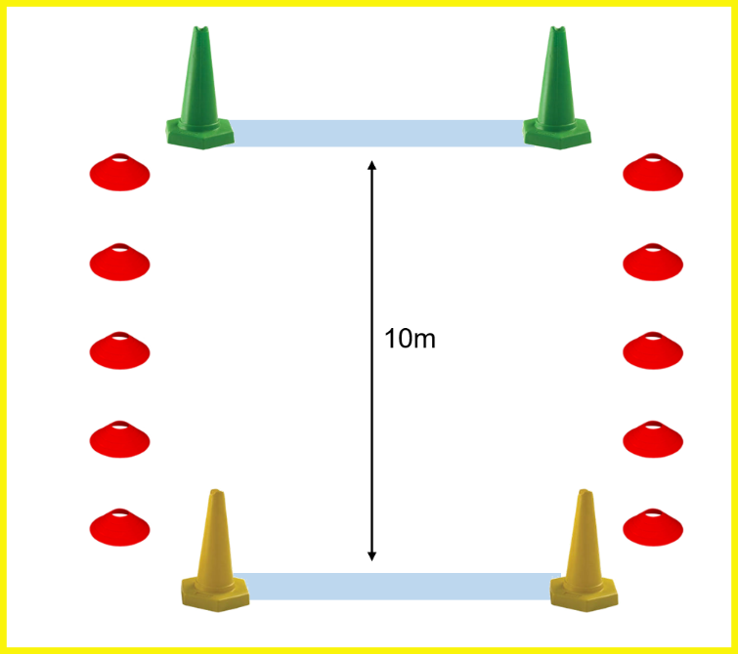
- Stopwatch
- Whistle or Start Flag
- Cones to mark sides of running area.

Set-up
- Set out 10m course with cones at either end.

Aim ‘ timed sprint over 10m.’

- Four lengths to complete the time.

Scoring:

Team Add the team times together (Based on 5 in a team)
Individual Player has two attempts to beat the time.

Adaptations
- Each go can be taken with a rest in between, if required.
- Distance (can be reduced/ extended depending on age or ability)
- VI: Leader/helper can clap in direction of cones or work as a guide
- HI: A paddle will give a visual cue to signal when to start.

EXAMPLE - Summer Team Results
Team Results  Timed event or number of goes added. | Murray Movement  (Number complete) | Rugby  (Add scores) | Direct Hit  (Add scores) | Parachute  (Times) | Tennis  (Highest Rally) | Long Jump  (Add scores) | Football  (Add scores) | Shuttle Run  (Add times) | Overall Points  Total  Lowest number of ‘Overall Points’ wins | Finishing  Position
Team  Yellow Class | 8 | 12 | 6 + 6= 12 | 1.55 mins | 10 | 4.30m | 16 | 2.30min
Position/Overall Points | 2nd | 4th | 4th | 2nd | 3rd | 1st | 3rd | 1st | 20pts | 2nd
Team  Red Class | 10 | 24 | 12 + 12= 24 | 1.45 mins | 5 | 3.50m | 12 | 3.20min
Position/Overall Points | 1st | 1st | 1st | 1st | 4th | 2nd | 4th | 3rd | 17pts | 1st
Team  Blue Class | 6 | 18 | 9+9=18 | 2.15 mins | 14 | 3.30m | 20 | 2.40min
Position/Overall Points | 3rd | 3rd | 3rd | 3rd | 2nd | 3rd | 2nd | 2nd | 21pts | 3rd
Team  Green Class | 4 | 21 | 12+9=21 | 2.30mins | 20 | 2.10m | 24 | 3.45min
Position/Overall Points | 4th | 2nd | 2nd | 4th | 1st | 4th | 1st | 4th | 22pts | 4th
EXAMPLE - Summer Individual Results

Individual Results | Murray Movement  (Add times) | Rugby  (Add times) | Direct Hit  (Highest scores) | Parachute  (Times) | Tennis  (Highest Rally) | Long Jump  (Add scores) | Football  (Add scores) | Shuttle Run  (Fastest time) | Overall Points  Total  Lowest number of ‘Overall Points’ wins | Finishing  Position
Name | 32 sec | 42 sec | 6 + 6= 12 | 1.55 mins | 10 | 3.10m | 9 | 45 sec
Position/Overall Points | 2nd | 4th | 4th | 2nd | 3rd | 1st | 3rd | 1st | 20pts | 2nd
Name | 30 sec | 24 sec | 12 + 12= 24 | 1.45 mins | 5 | 2.50m | 8 | 52 sec
Position/Overall Points | 1st | 1st | 1st | 1st | 4th | 2nd | 4th | 3rd | 17pts | 1st
Name | 40 sec | 40 sec | 9+9=18 | 2.15 mins | 14 | 2.40m | 10 | 50 sec
Position/Overall Points | 3rd | 3rd | 3rd | 3rd | 2nd | 3rd | 2nd | 2nd | 21pts | 3rd
Name | 55 sec | 35 sec | 12+9=21 | 2.30mins | 20 | 2.10m | 11 | 1.20 mins
Position/Overall Points | 4th | 2nd | 2nd | 4th | 1st | 4th | 1st | 4th | 22pts | 4th

Result Sheet- For Team or Individual
Team/Individual Name | Murray Movement  (Number complete or times) | Rugby  (Number complete or times) | Direct Hit  (Highest scores) | Parachute  (Times) | Tennis  (Highest Rally) | Long Jump  (Add scores) | Football  (Add scores) | Shuttle Run  (time/add times) | Overall Points  Total  Lowest number of ‘Overall Points’ wins | Finishing  Position
Team/Individual Name

Position/Overall Points
Team/Individual Name
Position/Overall Points
Team/Individual Name

Position/Overall Points
Team/Individual Name
Position/Overall Points
Panathlon Monitoring Form: Summer Games (Primary)

School Name:  County/Borough: |  |  |  | Disability – Number disabilities that apply  Key below |  |  |  |  |  |  |  | Ethnic Code  Key below
Total Number | Year Group | Leaders  (Age & No) | Gender  M / F | PI | HI | VI | SLD | MLD | AS | ManW/C | Pow  W/C | Code  e.g. 4 students x 1  2 students x 4
Pre-season

Game Day

KEY
Disability Physical Impairment (PI), Hearing Impairment (HI), Visual Impairment (VI), Severe Learning Disability (SLD)
Mild Learning Disability (MLD), Autistic Spectrum (AS), Manual Wheelchair (Man W/C), Power Chair (Pow W/C)
Ethnicity For each athlete, enter the code in the box provided (i.e. 1).
 |  | Ethnicity Code
1 = White | 2 = Mixed | 3 = Asian or  Asian British | 4 = Black or  Black British | 5 = Chinese or  Other Ethnicity

