
Gymnastic Resource Cards

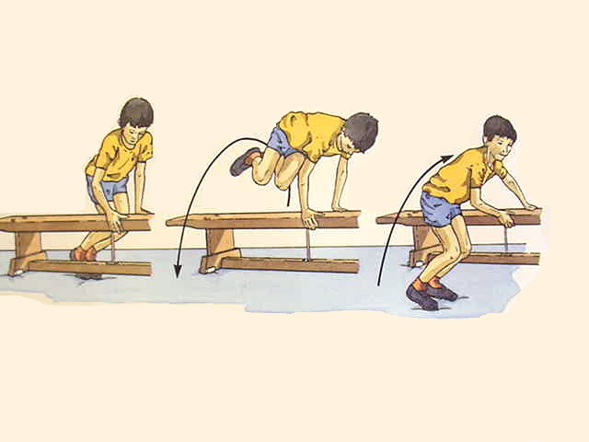
Basic Vaulting
Key Point
- Grip sides of bench firmly
- Keep your body tight
- Look at bench
- Hop your legs over the bench to the other side
- Keep your feet together for best performance

Think:

- Can I travel along the bench in this way?

- Can I hop over the bench going both ways?

- Can I get my hips high?

- How can I link this to my next move?

