
Gymnastic Resource Cards

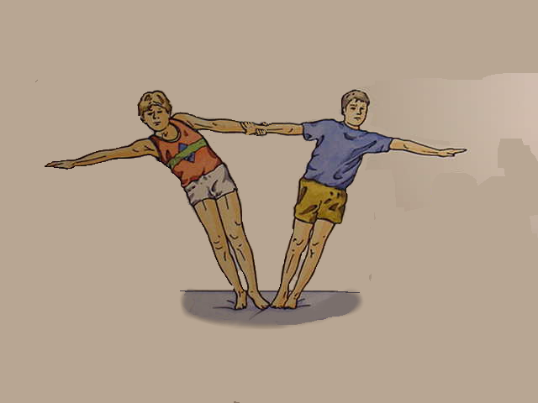
Counter-balance
Key Point
- Use each others body weight

- Feel the tightness in your body

- Hold the balance for 3 seconds

- Can you take one leg off the mat (outside leg)

Think:

- How could you both get out of this position?

- How could you both get into it?
3
Top Tip!

- Lean away slowly

- Let arms take the weight

