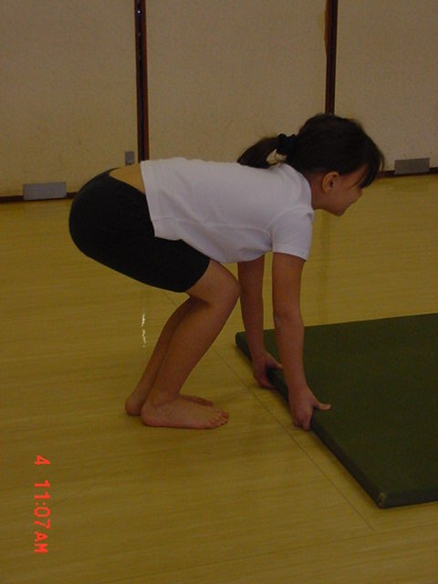

Key Concept – Safe Lifting / Carrying Technique

This supports the Gymnastics aspects of National Curriculum PE (2014) but also the wider agendas with keeping pupils safe and healthy now and for later in life, also afPE Safe Practice guidance (2020 – Chapter 3)
Can you see:
The difference between the two pupils back and hip positions?
A is the correct position, B the back is rounded and bent
That all the muscular work of lifting should be done by the legs not the back?
The need to teach safe, effective lifting technique?

To help the children evaluate and improve their technique:
• show them
• ask them to observe each other lifting the apparatus
• teach them safe lifting routines as part of the lesson
explain why
Stress their Safety!

A
B
Safe Practice in Physical Education, School Sport & Physical Activity

Apparatus Handling in Gymnastics

SELECT actions to create a simple movement phrase
!

☒

☑
Keeping the Pupils Safe: ensure that they………
Teach Safety – Teach Safely

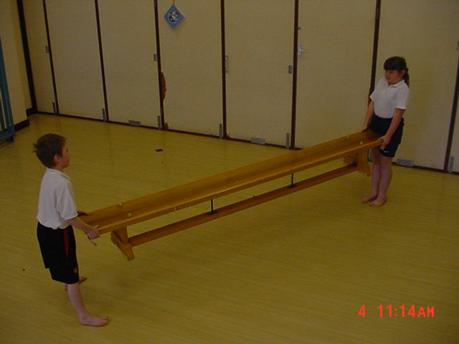
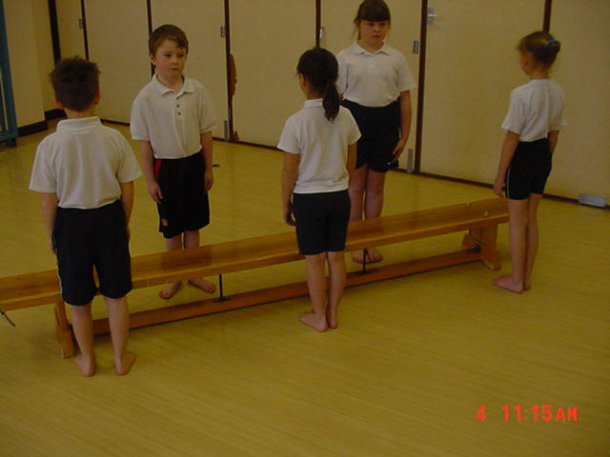
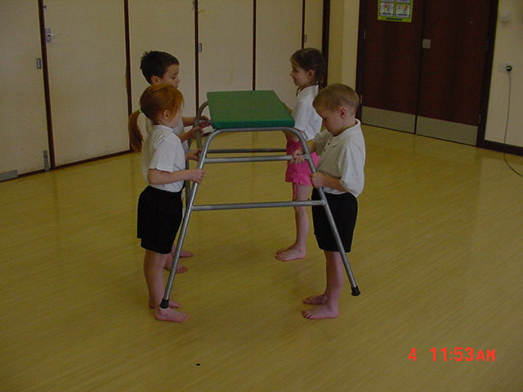
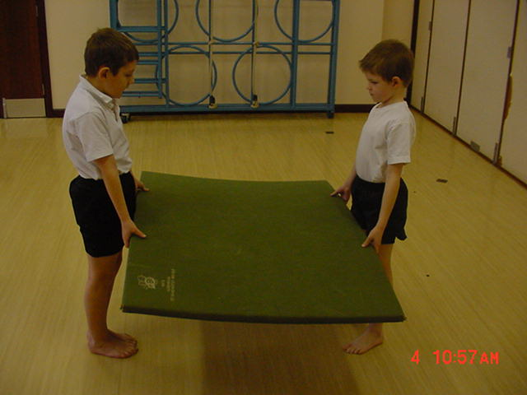
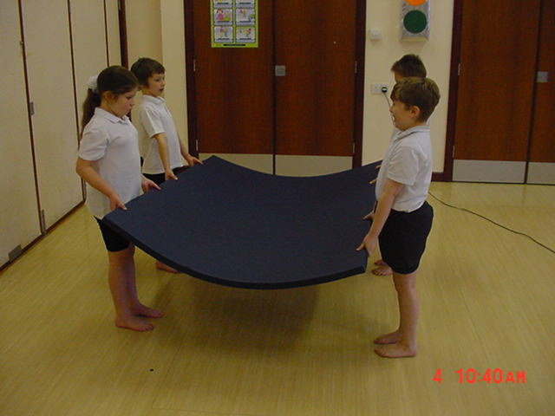
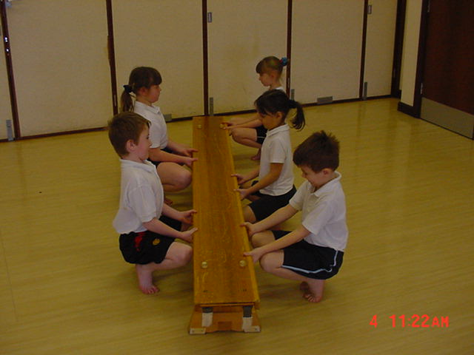

1,2,3 Lift
☒

Never have two lifters on the ends or allow them to walk backwards.
Leader to say “1,2,3 Lift”. All lift on “L” of Lift. No strain, straight backs, drive up with legs
Always carry apparatus along long side, never walk backwards, turn head to look forward.
With small, lightweight mats 2 is sufficient but don’t allow mat to bend.
4 for larger mats or smaller pupils. Always avoid folding, creasing and bending the mat
Have sufficient numbers. Position in “W” shape. No one will strain.

