Panathlon SEND Cricket Skills
Batting: In the ‘V’
Fielding: Direct Hit
Fielding: One Motion
Bowling: Line and Length
Fielding: Catches win matches
Batting: Wagon Wheel
Batting: Cricketing Nations
Bowling: Pitch Map

Thank you for electing to compete in the Panathlon SEND virtual cricket skills. This pack contains rules, results sheets, video clips and monitoring forms.

- This activity can be done in a competition format across 8 cricket challenges, see menu box above.(A school can take part in four activities one session and the remaining four in another session or across a series of sessions if required) or done internally within school as individuals

- Team event: Competitors take it in turns to complete each activity and the top 2 scores from the children are recorded for an overall team score for that activity. (Competitors within the team can only count for max 3 activities to allow others team members to score towards the total)

- Teachers will need to select their own ‘micro bubble’ sizes (Preferably min 5 - max 9) based upon their school risk assessments.

- Individually in school: Scores to be kept by the teacher enabling all individuals to “compete” among their school peers

- Upon completion: If schools have chosen as a team event , then they will need to submit their SEN team results and monitoring forms to entries@panathlon.com If the school has done it for individuals then schools supplies monitoring forms only to entries@panathlon.com
- Schools will then be sent certificates and stickers etc.
At the beginning of each challenge, explain the new activity. Where appropriate players keep their own equipment - or with new clean equipment.
Batting – In the ‘V’
Equipment
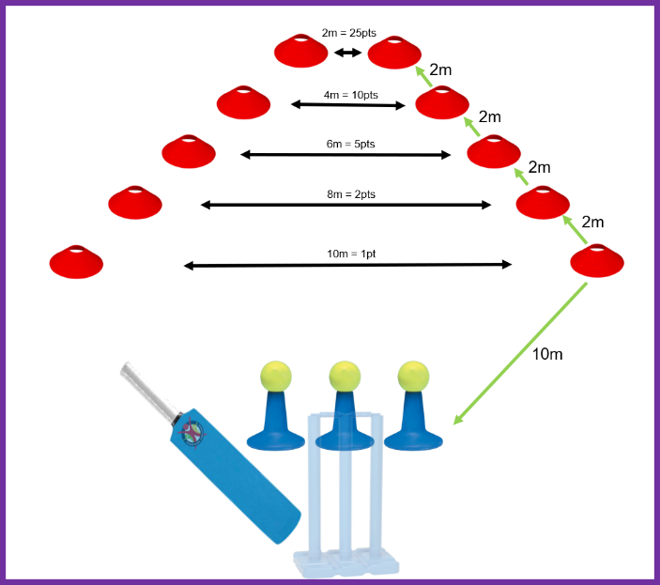
1 set of stumps (optional)
1 plastic cricket bat
3 balls – tennis balls ideal
3 tees (or cones) + 10 cones to mark target areas targets

Set up:
Batting: Set the 3 tees(cones) in front of the each of the stumps, with a tennis ball on top of each.
Target area: Should resemble a funnel shape.
- Set the closet and widest target positioned 10m from the batter. Place one pair of cones 10m apart.
- The next target is narrower and 12m from the batter. Place the cones 8m apart.
- The third target is 14m from the batter. Place the cones 6m apart.
- The fourth target is 16m from the batter. Place the cones 4m apart.
- The final target is 18m from the batter, Place the cones 2m apart.

Aim: Each player hits the 3 balls twice for ‘one over’ (6 balls) to score then joins the end of the queue for their second over (6 balls)
- Each batter should hit the ball out towards target areas and can aim for any target.

Scoring: Points are scored for the narrowest target the ball is hit through. However, 6 x 25 points is possible.
- 1st Target – 1 point
2nd Target – 2 points
3rd Target – 5 points
4th Target – 10 points
5th Target – 25 points
Teachers/ helpers record all the scores for each player. Then allocate either team or individual placings.
- Team: - Add the top two players scores together (best set of 6 balls x top two players)
- Individual: Add the total score for the player (best set of 6 balls to count)

Adaptations: A variation on this for older/more able to children is to “feed” the ball from under the chin so it drops on the ground rather than off of a tee.
- VI: An audible ball can be used, as audible balls will travel differently to a tennis ball, distances may need to vary.
- PI: A ramp can be used to propel the ball and be taken closer to the targets. The ball can be placed on a smaller cone to be delivered lower to the ground, or be hit after a bounce.
Fielding – Direct Hit
Video clip - https://youtu.be/tUgXuDH47kg

Equipment: 1 ball per player (bean bag), set of stumps (skittles/cardboard tubes or equivalent) 1 x cone
Set-up
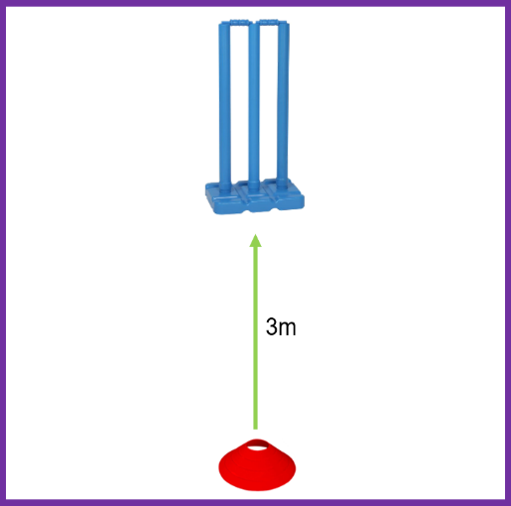
- Place one set of stumps/skittles 3 metres from a throw line.
Aim ‘Hit the stumps’
- A continuous team relay that gets more difficult.’ (aim at the stumps for points - take stumps away!)
- 1st round: The first competitor stands at the cone and rolls/underarm throws the ball towards the stumps, collect their ball, join the end of the queue. The next competitor takes their turn until everyone has had one attempt.
- 2nd round: Take the stump away leaving two. (Select a designated person to remove stumps)
- 3rd round: Take one stump away leaving one.
- NOTE: The next competitor does not throw until the previous player has collected their ball & rejoined the queue.
- After 3rd round, re-start the game for a second attempt to beat the score.

Scoring
- 1st round: 1 point, if any of the 3 stumps are hit.
- 2nd round: 2 points, if any of the 2 stumps are hit. (If unable to take away stumps-aim for outside stumps)
- 3rd round: 3 points, if the final stump is hit. (If unable to take away stumps-aim for middle stump)
- No points if the ball hits the base only, rather than a stump.
- Team: After two full rounds, add the top two individuals scores together (9 + 12= 21)
- Individual: Two full ‘rounds’ (3/2/1 stump) – add both scores together (1+2+3+0+0+3=9)
Adaptations
- VI: Leader/helper can clap near the stumps. Bell balls can create audio cue.
- Wheelchair users take their shots closer or use ramps to propel the ball

Fielding – One Motion
Equipment: 3 sets of Stumps
6 Balls
6 cones
Stopwatch

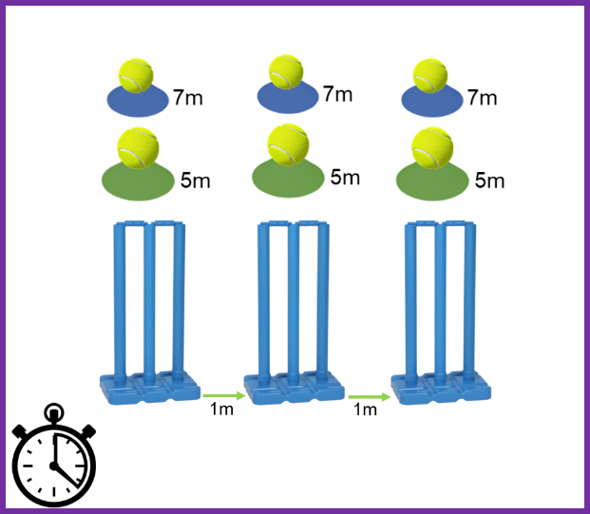
Set up: Place 3 sets of stumps in a straight line each 1 metre apart.
In front of each set of stumps place a cone at 5 metres then another at 7 metres with a ball on top.
Aim: ‘Run from the stumps to the cone and throw’
- On the shout of “go” the helper starts the stopwatch and the player runs from the first stump picks up a ball and throws at the stumps
- After each throw, the player runs back and touches the stumps before the run to the next ball.
- Balls can be picked up in any order to finish the player must run back past a set of stumps.
Scoring:
- All times are taken and recorded by the teacher/helper.
- For every throw which hits the stumps, 2 seconds are taken off the time and the original time is adjusted.
- Team score: The two quickest times from two players are added together. (e.g. 30 sec + 28 sec = 58 sec)
- Individual score: The fastest time run by the individual is recorded.( e.g. 40 sec)

Adaptations
- VI: The player could work with a guide. A helper can clap behind the stumps. Plastic bottles or stumps with bells can be used to make them audible.

Bowling – Line & Length
Equipment:
1 tennis or ideally, incrediball or windball
Cones or hoops
Stumps

Set up: From a bowling line measure 10m then set up 3 adjoining boxes with small cones or hoops.
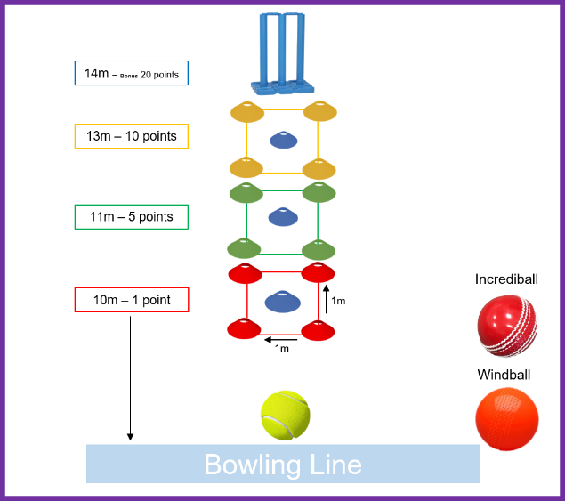
- Each box is 1m². (box 1 = 10m, box 2 = 11m, box 3 = 13m) There is a set of stumps at the end of the last box.(14m)
- Place a cone in the centre of each box.
Aim: Players must “bowl” the ball aiming for a direct hit in a ‘box’ . Bowling can be underarm or overarm.
- Allow 6 balls, then join the end of the queue for a second go.
Scoring: Points are scored based upon where the ball first hits. Player can aim for any box but only score on the first bounce.
- The nearest box is worth 1 point, the next box is worth 5 points and the furthest box, closest to the stumps is worth 10 points.
- In the centre of each box is another cone. If the ball hits the centre cone in any box on the first bounce, the score for that box is doubled.
- If the stumps are hit – no matter how many bounces have happened before – they score a bonus of 20. ( For example, the ball bounces in box 2 = 5 points then hits the stumps bonus 20. Total for the bowl = 25)
- Teachers/ helpers record all the scores for each player. Then allocate either team or individual placings.
- Team score: Add the top two players scores together (adding their best over (6 balls) together e.g. scores 40+ 20= 60)
- Individual score: Add the score for the player (adding their best over (6 balls) together e.g. score = 5 + 5+ 1 +0 + 10+ 0 = 21)
Adaptations This can be run as an underarm or proper overarm bowling game.
- VI: An audible ball can be used; the boxes could be marked out with ‘newspaper for sound. The ‘cone’ can be a plastic bottle with pasta in to make it audible.
- PI: A ramp can be used to propel the ball. Shots can be taken closer if needed.

Fielding – Catches win matches
Equipment:
1 tennis ball
1 x wall
2 cones
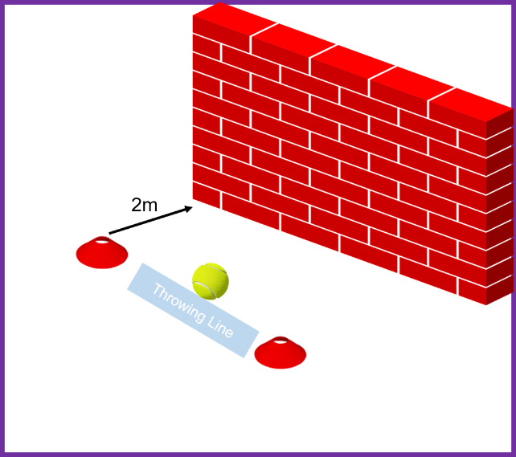
If a wall is not available, players can throw a tennis ball in the air and catch the ball as an individual.
Set up: Place a cone two metres from the wall to mark a throwing distance.
Aim: Each player must throw the ball onto the wall (if available) or in the air and catch it as many times as possible in a minute.
- Teacher/ helper has a stopwatch and shouts ‘go’. Players can work in pairs counting for each other.
Scoring:
- All catches are recorded by the teacher/helper at the end of one minute.
- If the ball is dropped, start throwing and catching again but keep your score- (Do not start from 1 again)
- Allow three goes to try to improve the players score.
- Team score: Add the top two players scores together (highest score in 1 minute e.g. 60 + 55= 115)
- Individual Score: The players highest score from three attempts ( e.g. 38)

Adaptations
- VI: An audible tennis ball can be used. The ball can be on a string to ease retrieval of a dropped ball.
- PI: Players can sit closer if needed and an extra bounce can be added for ages/abilities.

Batting – Wagon Wheel
Equipment:
1 tennis or ideally, incrediball or windball
Cones
Stumps
Cricket bat

Set up: Place the stumps on a batting line, mark 10 metres to the right with a cone and 10 metres to the left, mark with a cone.
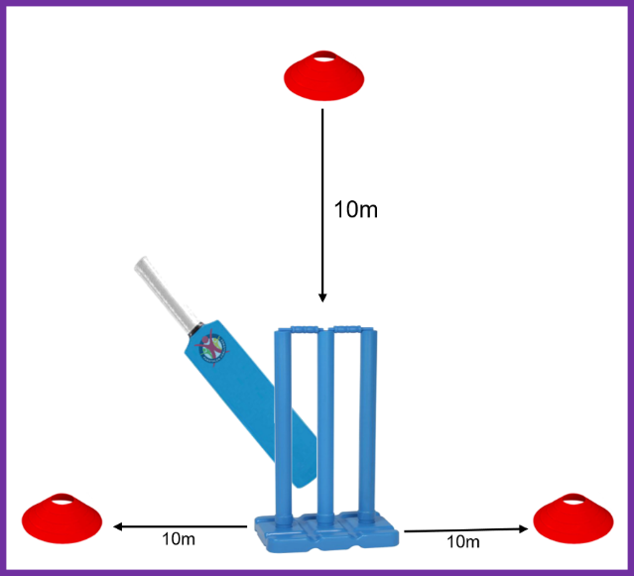
Place another cone 10 metres in front of the stumps as a bowling line.
Aim: To hit the ball with the bat and run to a cone either side of the wicket. The player can select which direction to run. (Right or left)
- Select a bowler, batter, wicket keeper and fielders.
- The bowler bowls from the 10 metre line, crease (Primary- underarm)
- Each batter has three balls bowled, and once hit runs to a cone and back if possible and continues until the ball returns, back to the bowler.
- Batter stops running when the ball returns, back to the bowler.
- After three bats they then join back in the team rotation, to help field or bowl.
- Allow each player a total of two bats. (6 balls)
Scoring: Points are scored each time the player reaches a cone. (2 points if they get there and back)
Teachers/ helpers record all the scores for each player. Then allocate either team or individual placings.
Team score: Top two individual scores from (6 bats)
Individual score: The number of points scored from two goes. ( 3 bats then another 3 bats)
Adaptations: VI: The player could work with a guide. Bell balls can create audio cue.

Batting: Cricketing Nations
Equipment:
6 x tennis or ideally, incrediball or windball
Cricket bat
Cones

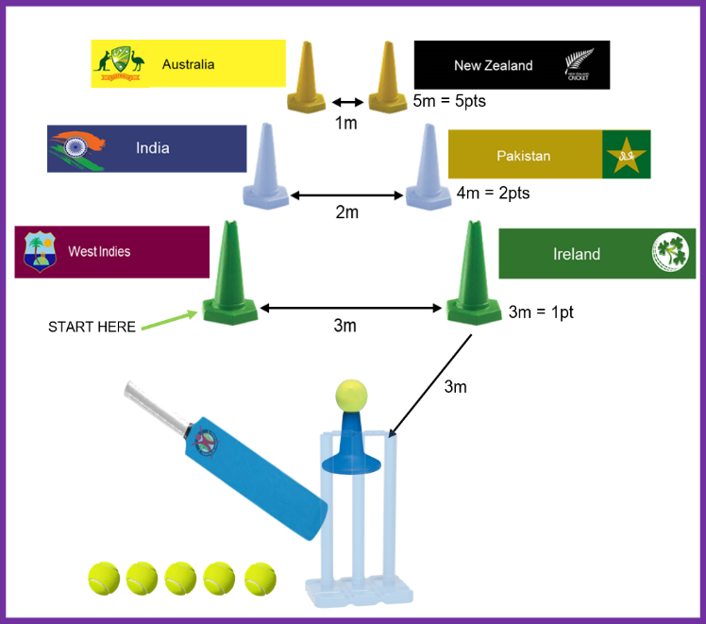
Set up:
Batting: Set one(cone) in front of the of the stumps, with a tennis ball on top.
Target area: Should resemble an inverted ‘V’ shape with each cone representing a country/area.
- Set the closet and widest target positioned 3m from the batter. Place one pair of cones 3m apart.
- The next target is narrower and 4m from the batter. Place the cones 2m apart.
- The third target is 5m from the batter. Place the cones 1m apart.

Aim: ‘To hit the cones’
- Each player hits 6 balls to score then joins the end of the queue for their second over (6 balls) .
- Each batter should hit the first ball out towards the nearest left target cone then continue in a clockwise order.
- West Indies, India, Australia, New Zealand, Pakistan, Ireland
- If the player misses the cone, they aim for the next one.

Scoring: Points are scored when the ‘cone’ target is hit.
1st cones = 1 point
2nd cones = 2 points
3rd cones = 5 points
Max points - 1+ 2 + 5+ 5+ 2 + 1 = 16

Team: - Add the top two players scores together (best set of 6 balls x top two players)

Individual: Add the total score for the player (best set of 6 balls to count)

Adaptations:
- VI: Leader/helper can clap near the cones. Bell balls can create audio cue.
- Wheelchair users take their shots closer.

Bowling: Pitch Map
Equipment:
6 x tennis or ideally, incrediball or windball
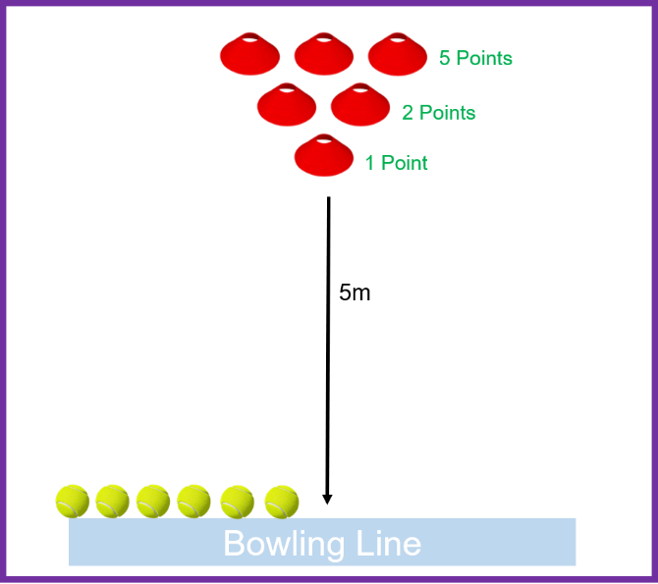
Cricket bat
Cones

Set-up: Cones are set out in an inverted triangle 5 metres from the bowling line (Crease)

Aim: Players must “bowl” the ball aiming for a direct hit on any cone. Bowling can be underarm or overarm.
- If successful, the player collects the cone and brings it back to the throw line.

- Allow 6 balls for a score then join the end of the team queue.

- Repeat if time allows within the lesson.

Scoring: Points are scored when a ‘cone’ target is hit.

- 1st cone = 1 point
- Middle cones = 2 points
- Back row cones = 5 points
- Max points - 1+ 2 + 2 + 5+ 5 + 5 = 20

Team score: Add the top two players scores together (adding their best over (6 balls)
Individual score: Add the score for the player (adding their best over (6 balls) together e.g.

Adaptations: VI Players: Leaders clap in direction of cone.
Wheelchair users can deliver their shot slightly closer if required.

EXAMPLE - Cricket Team Results
Team Results:  Top two individuals in the team added together. | Batting:  In the ‘V’  (Highest scores) | Fielding:  Direct Hit  (Highest scores) | Fielding:  One Motion  (Fastest times) | Bowling: Line and Length  (Highest scores) | Fielding:  Catches win matches  (Highest scores) | Batting:  Wagon Wheel  (Highest scores) | Batting:  Cricketing Nations  (Highest scores) | Bowling:  Pitch Map  (Highest scores) | Overall Points  Total  Lowest number of ‘Overall Points’ wins | Finishing  Position
Team  Yellow Class | 60+ 90= 150 | 6 + 6= 12 | 32 + 28 = 60 | 42+ 20= 62 | 30 + 30= 60 | 4+ 5= 9 | 16 + 16 = 32 | 10 + 15=25
Position/Overall Points | 1st | 4th | 2nd | 3rd | 1st | 3rd | 1st | 3rd | 18pts | 2nd
Team  Red Class | 75+ 60= 135 | 12 + 12= 24 | 30 + 28 = 58 | 40+ 20= 60 | 30 + 25= 55 | 4 + 4 = 8 | 14 + 14 = 28 | 20 + 20=40
Position/Overall Points | 2nd | 1st | 1st | 4th | 2nd | 4th | 2nd | 1st | 17pts | 1st
Team  Blue Class | 75+ 50= 125 | 9+9=18 | 34 + 28 = 62 | 40+ 24= 64 | 30 + 18 = 48 | 5 + 5= 10 | 14 + 6 = 20 | 15 + 15=30
Position/Overall Points | 3rd | 3rd | 3rd | 2nd | 3rd | 2nd | 3rd | 2nd | 21pts | 3rd
Team  Green Class | 50+ 60=110 | 12+9=21 | 36 + 28 = 64 | 40+25= 65 | 15 + 20 = 35 | 6 + 5= 11 | 6 + 6 = 12 | 10 + 5=15
Position/Overall Points | 4th | 2nd | 4th | 1st | 4th | 1st | 4th | 4th | 24pts | 4th
EXAMPLE - Cricket Individual Results
Individual Results | Batting:  In the ‘V’  (Highest scores) | Fielding:  Direct Hit  (Highest scores) | Fielding:  One Motion  (Fastest times) | Bowling: Line and Length  (Highest scores) | Fielding:  Catches win matches  (Highest scores) | Batting:  Wagon Wheel  (Highest scores) | Batting:  Cricketing Nations  (Highest scores) | Bowling:  Pitch Map  (Highest scores) | Overall Points  Total  Lowest number of ‘Overall Points’ wins | Finishing  Position
Name | 90 | 3 | 32 | 20 | 30 | 4+ 5= 9 | 16 | 10
Position/Overall Points | 1st | 4th | 2nd | 3rd | 1st | 3rd | 1st | 3rd | 18pts | 2nd
Name | 75 | 12 | 28 | 11 | 25 | 4 + 4 = 8 | 14 | 20
Position/Overall Points | 2nd | 1st | 1st | 4th | 2nd | 4th | 2nd | 1st | 17pts | 1st
Name | 60 | 6 | 34 | 40 | 18 | 5 + 5= 10 | 12 | 15
Position/Overall Points | 3rd | 3rd | 3rd | 2nd | 3rd | 2nd | 3rd | 2nd | 21pts | 3rd
Name | 50 | 9 | 36 | 42 | 15 | 6 + 5= 11 | 6 | 5
Position/Overall Points | 4th | 2nd | 4th | 1st | 4th | 1st | 4th | 4th | 24pts | 4th
Result Sheet- For Team or Individual
Team/Individual Name | Batting:  In the ‘V’  (Highest scores) | Fielding:  Direct Hit  (Highest scores) | Fielding:  One Motion  (Fastest times) | Bowling: Line and Length  (Highest scores) | Fielding:  Catches win Matches  (Highest scores) | Batting:  Wagon Wheel  (Highest scores) | Batting:  Cricketing Nations  (Highest scores) | Bowling:  Pitch Map  (Highest scores) | Overall Points  Total  Lowest number of ‘Overall Points’ wins | Finishing  Position
Team/Individual Name

Position/Overall Points
Team/Individual Name
Position/Overall Points
Team/Individual Name

Position/Overall Points
Team/Individual Name
Position/Overall Points
Panathlon Cricket Monitoring Form
School Name:  County/Borough: |  |  |  | Disability – Number disabilities that apply  Key below |  |  |  |  |  |  |  | Ethnic Code  Key below
Total Number | Year Group | Leaders  (Age & No) | Gender  M / F | PI | HI | VI | SLD | MLD | AS | ManW/C | Pow  W/C | Code  e.g. 4 students x 1  2 students x 4
Pre-season

Game Day

KEY
Disability Physical Impairment (PI), Hearing Impairment (HI), Visual Impairment (VI), Severe Learning Disability (SLD)
Mild Learning Disability (MLD), Autistic Spectrum (AS), Manual Wheelchair (Man W/C), Power Chair (Pow W/C)
Ethnicity For each athlete, enter the code in the box provided (i.e. 1).
 |  | Ethnicity Code
1 = White | 2 = Mixed | 3 = Asian or  Asian British | 4 = Black or  Black British | 5 = Chinese or  Other Ethnicity

