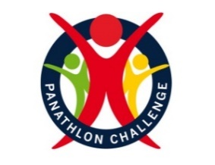

Secondary Summer Panathlon
Javelin | Tennis
Rugby | Tri Golf
Direct Hit | Football
Stick Slalom | Shuttle Run

Thank you for electing to take part in the secondary summer multi-skills. This pack contains: rules, results templates for internal use, video clips and monitoring forms.

Summer multi-skills enables competitors can take part in a series of activities across several weeks or sessions. Individual schools can select their own activities based upon their own judgements regarding facilities, zones, teaching bubbles, equipment, time allocated, current national guidelines, school policies and risk assessments.

General Guidelines
- Activities can be run by the class teacher or with the help of additional leaders/helpers.
- Teachers will need to select their own team ‘micro bubble’ sizes based upon their risk assessments.
- Each ‘micro bubble/team’ will move to each activity via set ‘zones’ in accordance with school policy.
- Schools can select activities from the menu and decide upon their own length of time to complete the activities i.e. 5 minutes per activity or a set number of goes (based on individuals or equal size teams).
- Mainstream students can work alongside SEN students to enable the activities to take place then score the SEN competitor as an individual.
- Schools can choose to record team/ bubble or individual scores and opt to produce their own school rankings for internal use.

Equipment Guidelines
- Where possible, one piece of equipment each, rather than shared.
- Ensure that equipment is safe after each activity to stop slips and trips when rotating to each zone.

To receive certificates, send a completed monitoring form to entries@panathlon.com

Javelin
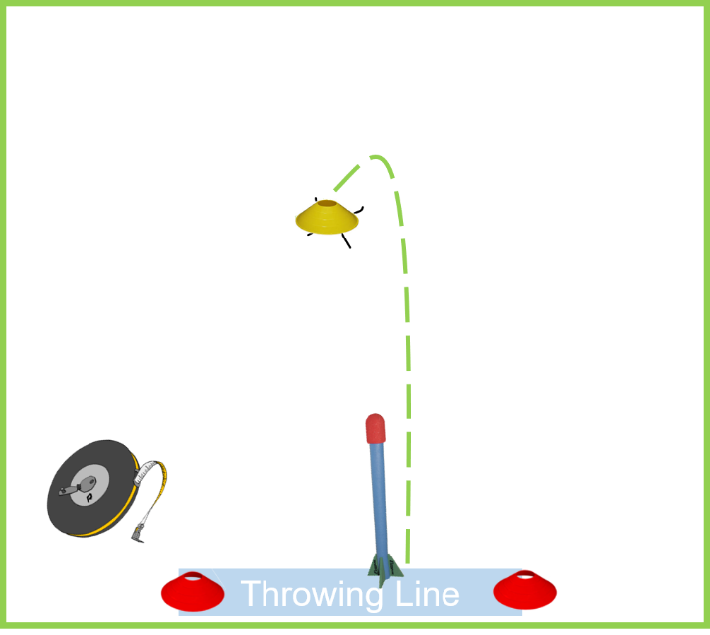
Equipment: Foam Javelin, 3 cones

Set-up
- 2 x cones to form the throw line.
- 1 x cones per competitor for measuring,

Aim
Each player has 3 attempts to throw a javelin as far as they can with the aim of trying to beat each throw.
- Allocate each player a small, different coloured cone.
- After each throw ask the teacher/helper to place the players cone on the exact area that the javelin first hits the ground.
- Move the cone forwards each time that the player throws further. (do not move the cone backwards if the throw is shorter on any attempt)
Scoring
After the third throw measure the exact distance with the tape measure for an accurate score.
Record the best distance thrown for each player then allow them to start again and repeat the three throws.
- Team score: Add the top two players ‘best’ distances together. ( e.g., 15m + 20m)
- Individual score: Record the ‘best’ throw. (e.g., 14m)

Adaptations
- VI - leader/helper can clap in direction of cones.
- Wheelchair users – can do a seated throw.

Chipper (Rugby Version)

Video Link: https://youtu.be/9C9j1PW9GK4

Equipment
- 1 x small rugby ball
- 6 x Hoops
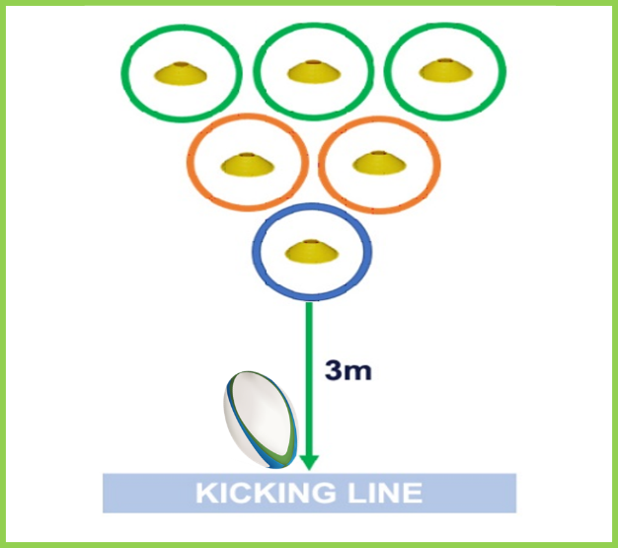
- 6 cones
Set up
- A kick line is marked with tape 3m from the front row of three hoops.
- The hoops are set out in an inverted triangle, as per the diagram with a cone placed inside each hoop

Aim “Chip the ball into all of the 6 hula hoops.”
- 1 player at a time.
- Player has 3 consecutive attempts before the next player goes.
- Players chip the ball from the kick line to land directly into a hoop
- Only one score per chip, taken from wherever the ball first touches the floor
- Once successful, the cone is removed from inside that hoop
- Players then aim for the remaining hoops with a cone inside
- Continuous relay within 5 minutes
Scoring
- 2 points scored when player chips their ball into a hoop with a cone inside
- 1 point scored when player chips their ball into a hoop without a cone inside
- Do not reset the cones for each player. As a team the players are trying to collectively chip the ball into all 6 hoops. 5 Bonus points are awarded if the team achieves this.
- Re-set all 6 cones inside the hoops and play continues again
- Team: Add together all the points scored, within 5 minutes.
- Individual: Three turns of 3 attempts each. Add all scores/points together.

Adaptations
- Visually Impaired: A bell ball will create an audio cue to aid direction of the ball.
- Hearing Impaired: A paddle will give a visual cue to signal a players turn.
- Wheelchair Users: Use a first or the heel of their hand to volley the ball or bounce pass the football into the target areas.

.
Direct Hit
Video clip - https://youtu.be/tUgXuDH47kg

Equipment: 1 ball per person (bean bag), set of stumps (skittles/cardboard tubes or equivalent) 1 x cone
Set-up
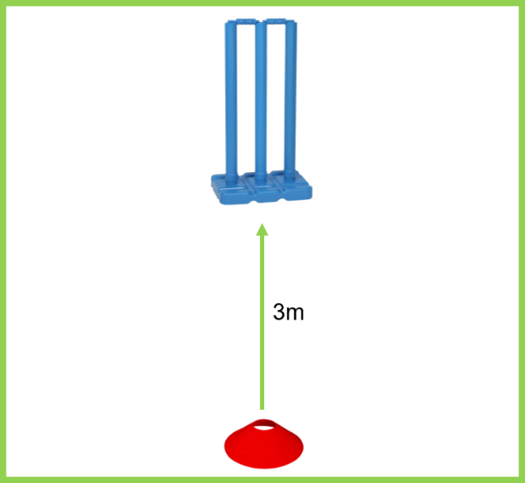
- Place one set of stumps/skittles 3 metres from a throw line.
Aim ‘Hit the stumps’
- A continuous team relay that gets more difficult.’ (aim at the stumps for points - take stumps away!)
- 1st round: The first competitor stands at the cone and rolls/underarm throws the ball towards the stumps, collect their ball, join the end of the queue. The next competitor takes their turn until everyone has had one attempt.
- 2nd round: Take the stump away leaving two. (Select a designated person to remove stumps)
- 3rd round: Take one stump away leaving one.
- NOTE: The next competitor does not throw until the previous player has collected their ball & rejoined the queue.
- After 3rd round, re-start the game for a second attempt to beat the score.

Scoring
- 1st round: 1 point, if any of the 3 stumps are hit.
- 2nd round: 2 points, if any of the 2 stumps are hit. (If unable to take away stumps-aim for outside stumps)
- 3rd round: 3 points, if the final stump is hit. (If unable to take away stumps-aim for middle stump)
- No points if the ball hits the base only, rather than a stump.
- Team: Add every score to give the team/bubble total, within 5 minutes if timing or two full rounds.
- Individual: Two full rounds (3/2/1 stump) – add scores together (1+2+3+0+0+3=9)
Adaptations
- VI: Leader/helper can clap near the stumps.
- Bell balls can create audio cue.
- Wheelchair users take their shots closer or use ramps to propel the ball.
Stick Slalom

Video Clip - https://youtu.be/KzneOkN3fgk

Equipment: 1 x Hockey stick each, ball, 17 x cones.

Set-Up
Cones are set out 50cm apart (measured from end of cone) with chalk or floor markings showing the direction. 3.5m x 3.5m

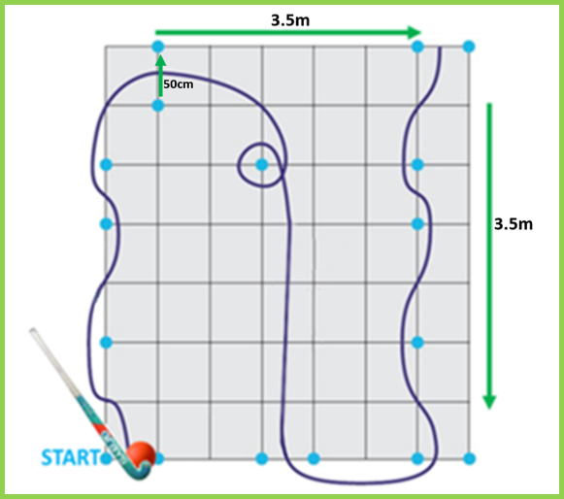
Aim ‘Team members take it in turns to complete a slalom’
Competitors complete the course around the cones, keeping the ball in contact with the hockey stick. Go back to the cone - if missed.

Scoring

- Team: Number of completed slaloms, in 5 minutes

- Individual: 2 attempts. Add times together.

Adaptations
- Bell balls can aid VI players.
- VI competitors can choose to follow a leader through the course or have a guide as assistance.
- A visual cue is to be given by the leader to start the slalom as well as audio. For example, say ‘go’ and lower an arm.
- Wheelchair users can carry a ball and can be pushed.
- Activity can be varied using a football to dribble or tennis racket to balance a ball.

Rally Tennis

Video Clip https://youtu.be/FZ4dT48kZ2o

Equipment
Ball, tennis racket or equivalent per child, tape. (rackets to be wiped after each go)

Set-up
Mark out the court area with tape. Use half a badminton court in width or (2m width) length 6 m (no net)

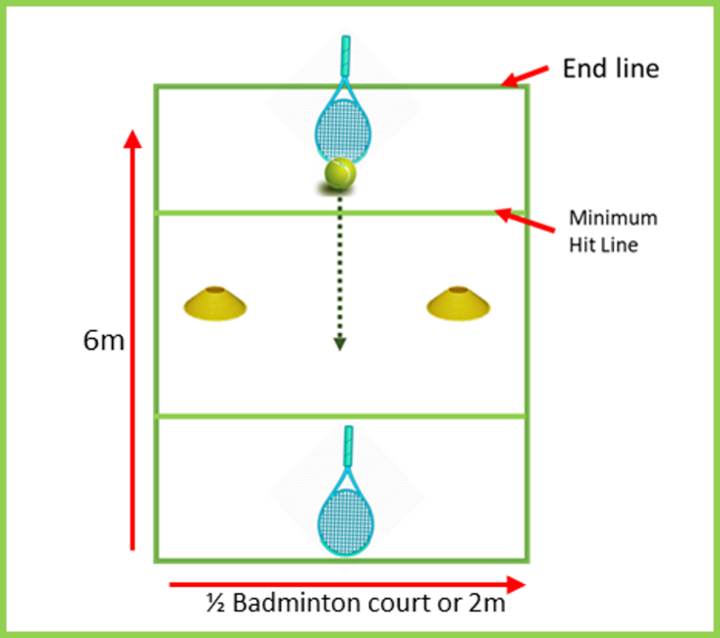
Aim ‘ Count the rally’
Two competitors stand and aim to push/roll the ball in a continuous rally on a small court between two cones. The ball must go past the minimum hit line (2m)

The rally ends when:
- The ball lifts from the floor
- The ball goes past the end line
- The ball hits a player’s body, including hand
- The ball does not pass between the cones
- The ball is hit inside the minimum hit line
- The ball stops within the minimum hit line

Rotate each pair after each rally ends (Max rally 30 secs)

Scoring

Team: The highest rally for the team is recorded

Individual: Highest score with a partner

Adaptations
- Bell balls can aid VI players.
- Wheelchair users can use their chair to stop the ball, this does not affect rally count (side on using the big wheel, taking extra care when pushing from backwards to forwards),
- Wheelchair users could also use a cricket bat/hockey stick if unable to reach to the floor, but ball must still stay along floor.

Tri Golf – Finders Keepers
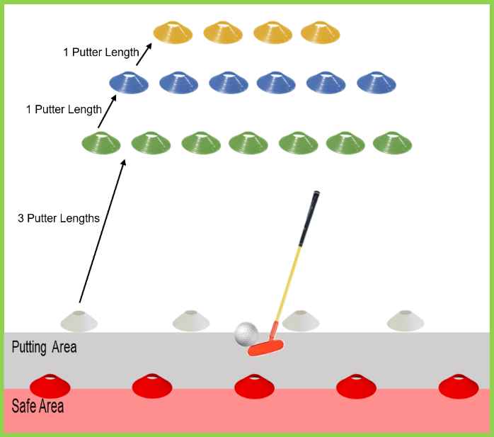
Equipment
- Cones
- Golf putters
- Small ball

Set-up See diagram as example.
- Red cones for players to stand behind in safe area. (3 lengths of putter back from white cone)
- White cones for start line.
- Green, Blue Yellow cones as target areas.
.
Aim ‘Hit the cone’ to score points as a relay.

- Taking it in turns players Putt the ball towards the cones.
- The first cone hit by the ball is collected by the player and placed in a scoring stack.
(Collect one cone per player).
- The player then rotates to join the end of the queue in the safe area and the next players putts the ball.
- Once all cones have been collected the game can be set out again if time allows.
Scoring
- Points awarded for each cone hit - Yellow 10 points, Blue 5 points, Green 1 point.
- Team: Add every score for a team/bubble total within the time or a set number of goes per player.

- Individual competitor: Five minutes to see how many points they score. (Or a set number of goes)

Adaptations
- VI - leader/helper can clap in direction of cones.
- Wheelchair users – use the tri putter or tennis racket.

Dribbling Weave

Video Link: https://youtu.be/tOynyGXsAHo

Equipment
- 1 x Football
- 6 x Cones, to weave around.
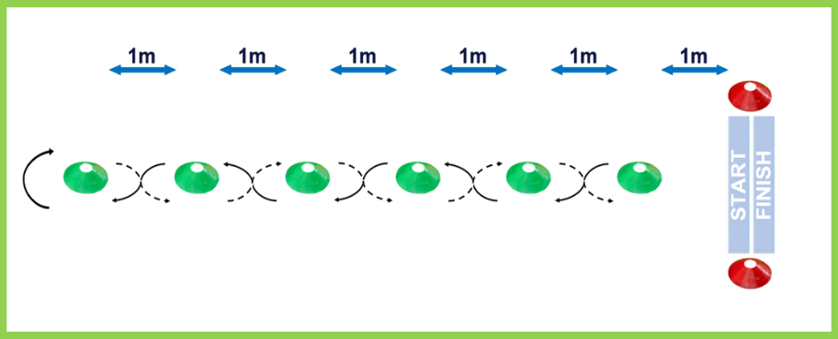
- 2 x Further Cones, for start/finish (Tape, Chalk, Grass Marking Paint, Floor Line)

Set up
- Start/Finish line is 1m from the first cone. Place 6 cones 1m apart in a straight line.

Aim “Dribble a football between cones, there & back”.
- 1 player at a time.
- Start and finish in the same place.
- Ask the player to stop the ball on the Start Line for the next player (rather than pass).
- Continuous relay for 5 minutes.

Scoring
- 2 points are scored for successfully weaving ‘up’ between all the cones and 2 points are scored for successfully weaving ‘down’ between all the cones, back to the start line.
- 1 point is awarded for weaving ‘up’ or ‘down’ if any weaves are missed or cones are hit by the ball.
- A maximum of 4 points and minimum of 2 points can be scored in any players attempt.

Team: Total number of points scored, within 5 minutes or (3 goes each based on equal team sizes)

Individual: Player has 3 goes (there and back) and adds all their scores together. Each go can be taken with a rest in between, if required.

Adaptations
- To simplify take away every other cone.
- VI: A bell ball will create an audio cue to aid direction of the ball. Leader/helper can clap in direction of cones.
- HI: A paddle will give a visual cue to signal when to start.
- Wheelchair users: Can carry the ball on their lap around the course.

Shuttle Run

Equipment
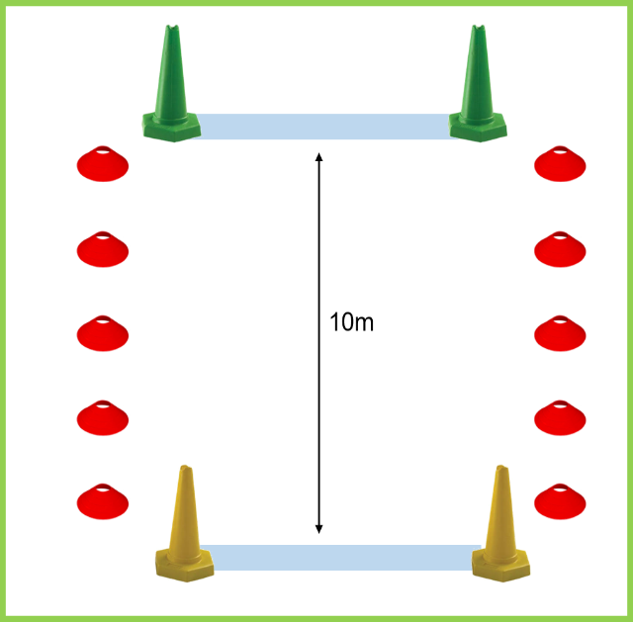
- 4 x Large Cones
- Stopwatch
- Whistle or Start Flag
- Cones to mark sides of running area.

Set-up
- Set out 10m course with cones either end.

Aim ‘ Timed sprint over 10m.’

- Four lengths to complete the time.

Scoring

Team Add the team times together (Based on 5 in a team)

Individual Player has two attempts to beat the time. Each go can be taken with a rest in between, if required.

Adaptations

- Distance (can be reduced/ extended depending on age or ability)
- VI: Leader/helper can clap in direction of cones or work as a guide
- HI: A paddle will give a visual cue to signal when to start.

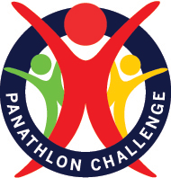
EXAMPLE - Summer Team Results
Team Results  Timed event or number of goes added. | Javelin  (Longest throws) | Rugby Chip  (Add scores) | Direct Hit  (Add scores) | Stick Slalom  (Number complete) | Tennis  (Highest Rally) | Tri Golf  (Add scores) | Football  (Add scores) | Shuttle Run  (Add times) | Overall Points  Total  Lowest number of ‘Overall Points’ wins | Finishing  Position
Team  Yellow Class | 20+ 15= 35 | 12 | 6 + 6= 12 | 8 | 10 | 30 | 16 | 2.30min
Position/Overall Points | 1st | 4th | 4th | 2nd | 3rd | 1st | 3rd | 1st | 19pts | 2nd
Team  Red Class | 18+ 16= 34 | 24 | 12 + 12= 24 | 10 | 5 | 25 | 12 | 3.20min
Position/Overall Points | 2nd | 1st | 1st | 1st | 4th | 2nd | 4th | 3rd | 18pts | 1st
Team  Blue Class | 15+ 12= 27 | 18 | 9+9=18 | 6 | 14 | 20 | 20 | 2.40min
Position/Overall Points | 3rd | 3rd | 3rd | 3rd | 2nd | 3rd | 2nd | 2nd | 21pts | 3rd
Team  Green Class | 10+ 15=25 | 21 | 12+9=21 | 4 | 20 | 15 | 24 | 3.45min
Position/Overall Points | 4th | 2nd | 2nd | 4th | 1st | 4th | 1st | 4th | 22pts | 4th
EXAMPLE - Summer Individual Results
Individual Results | Javelin  (Longest throws) | Rugby Chip  (Highest scores) | Direct Hit  (Highest scores) | Stick Slalom  (Add Times) | Tennis  (Highest Rally) | Tri Golf  (Add scores) | Football  (Add scores) | Shuttle Run  (Fastest time) | Overall Points  Total  Lowest number of ‘Overall Points’ wins | Finishing  Position
Name | 20m | 12 | 6 + 6= 12 | 1.55 mins | 10 | 30 | 9 | 45 sec
Position/Overall Points | 1st | 4th | 4th | 2nd | 3rd | 1st | 3rd | 1st | 19pts | 2nd
Name | 18m | 24 | 12 + 12= 24 | 1.45 mins | 5 | 25 | 8 | 52 sec
Position/Overall Points | 2nd | 1st | 1st | 1st | 4th | 2nd | 4th | 3rd | 18pts | 1st
Name | 15m | 18 | 9+9=18 | 2.15 mins | 14 | 20 | 10 | 50 sec
Position/Overall Points | 3rd | 3rd | 3rd | 3rd | 2nd | 3rd | 2nd | 2nd | 21pts | 3rd
Name | 10m | 21 | 12+9=21 | 2.30mins | 20 | 15 | 11 | 1.20 mins
Position/Overall Points | 4th | 2nd | 2nd | 4th | 1st | 4th | 1st | 4th | 22pts | 4th
Result Sheet- For Team or Individual
Team/Individual Name | Javelin  (Longest throws) | Rugby Chip  (Highest scores) | Direct Hit  (Highest scores) | Stick Slalom  (Times/number complete) | Tennis  (Highest Rally) | Tri Golf  (Add scores) | Football  (Add scores) | Shuttle Run  (time/add times) | Overall Points  Total  Lowest number of ‘Overall Points’ wins | Finishing  Position
Team/Individual Name

Position/Overall Points
Team/Individual Name
Position/Overall Points
Team/Individual Name

Position/Overall Points
Team/Individual Name
Position/Overall Points
Panathlon Monitoring Form: Summer Games (Secondary)
School Name:  County/Borough: |  |  |  | Disability – Number disabilities that apply  Key below |  |  |  |  |  |  |  | Ethnic Code  Key below
Total Number | Year Group | Leaders  (Age & No) | Gender  M / F | PI | HI | VI | SLD | MLD | AS | ManW/C | Pow  W/C | Code  e.g. 4 students x 1  2 students x 4
Pre-season

Game Day

KEY
Disability Physical Impairment (PI), Hearing Impairment (HI), Visual Impairment (VI), Severe Learning Disability (SLD)
Mild Learning Disability (MLD), Autistic Spectrum (AS), Manual Wheelchair (Man W/C), Power Chair (Pow W/C)
Ethnicity For each athlete, enter the code in the box provided (i.e. 1).
 |  | Ethnicity Code
1 = White | 2 = Mixed | 3 = Asian or  Asian British | 4 = Black or  Black British | 5 = Chinese or  Other Ethnicity

