
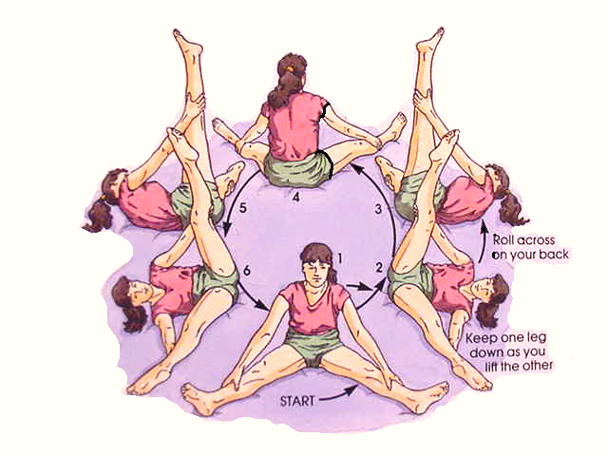
Gymnastic Resource Cards
Rolling
A simple individual rolling action
Top Tip!
Keep your legs tense and tight to make the leg swing easier
This movement is sometimes called a “Teddy Bear Roll”

