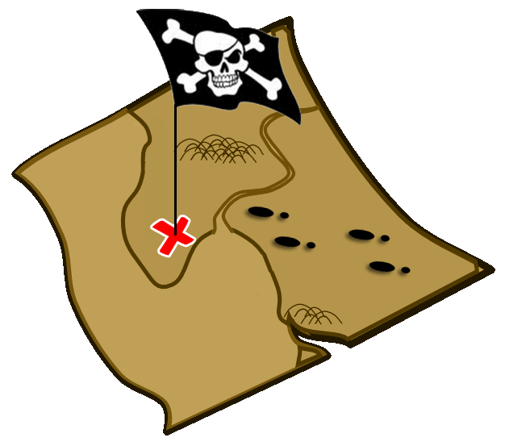
Treasure Island Ahoy!

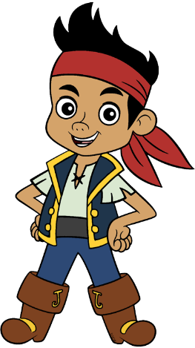
Sketch out the Pirate Island in the space below. Draw the coast-line, then add in features. Listen to the tutor to what you do next!

