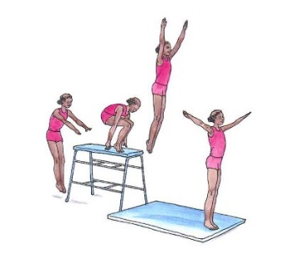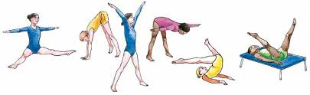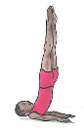**Planning Support Material – Understanding, Challenge, Differentiate, course support.**

Use of ICT

for

Learning

(Including assessment)

Feedback

**e.g. Visual / Verbal**

**Focus on key Teaching Points**

**Self-Assessment**

**Peer Assessment**

**Teacher**

Independent

Expectations

* **Quality & Behaviour**

Use of Video

**e.g. taken in lesson**

**QUALITY OF MOVEMENT**

*Can you help your pupils by challenging them to practise, refine, adapt to show:-*

* **Control**
* **Coordination**
* **Accuracy / Precision**
* **Balance**
* **Agility**
* **Adapt** *(e.g. different types of wide positions – as above graphic, balance on smaller base)*
* **Extension & Tension** *(e.g. stretched arms, pointed fingers / toes as in graphic)*
* **Poise**
* **Flow / Fluidity** *(the end of one movement is the beginning of next)*

**RELATIONSHIP**

* Matching / Mirroring
* Canon / Unison
* Compare / Contrast
* Action / Reaction
* Counter Tension / Counter Balance
* Symmetry / Asymmetry
* With each other

**How YOU Move**

**(Think of as an ADVERB)**

e.g. quickly, heavily, lightly, spikey, fluidly,

**SPACE**

* Where?
* How you travel / cover the area
* Where you start in relation to partner / group

**SPEED**

* Fast
* Medium
* Slow
* Pulse / Rise

**LEVELS**

* High
* Medium
* Low
* On Apparatus
* Using a Partner

**DIRECTION**

* Pathways
* Different Body Parts Leading the Movement
* Over / under / through etc.

In Gymnastics there are 5 Basic Body Actions

**TRAVEL TURN JUMP BALANCE BODY SHAPE**

In Teaching Gymnastics we can build and extend learners knowledge, skills & understanding by using

Progression

**e.g. Floor to Apparatus**

Routines

**e.g. for learning**

ASSESSMENT

(Impact)

DELIVERY

(Implementation)

LEARNING

Matched to Pupils’ Needs

Demonstration

**Modelling, VAK**

PLANNING

(Intent)