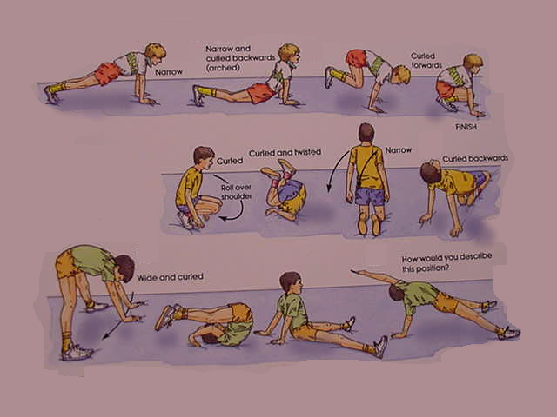

Gymnastic Resource Cards
Rolling
Simple individual rolling actions which use curled and wide shapes
3
3
Hold the balance position for 3 seconds where you see this sign.
Key question: Can you perform some parts of the movement at different speeds?
Can you still show control and co-ordination?
Look at the stretched, straight arms, try to copy
Hands take weight so that only the shirt collar touches the mat – never the head
Safety:
Only to be attempted by pupils who can support their body weight using their arms.

