
Gymnastic Resource Cards

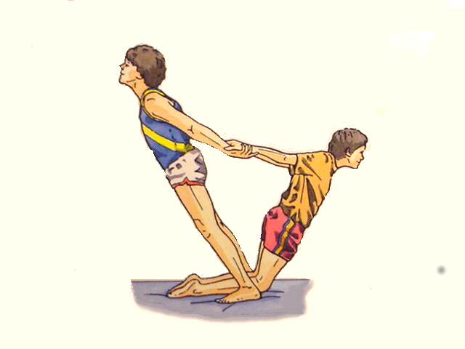
Counter-balance
Key Point
- Use each others body weight

- Feel the tightness in your body – core strong

- Hold the balance for 3 - 5 seconds

Think:

- How could you both get out of this position?

- How could you both get into it?
Top Tip!
- Lean away slowly
- Let arms take the weight

