Netball Numbers – Basic Orienteering

Resources:
- Netball court maps, 15 maps laminated which follow different lines, directions etc.
- Each set of maps to be placed in separate box or bag

- 14 cones or markers labelled with the code numbers as follows:

- 4 with number 1 (point)
- 4 with number 2 (pts)
- 4 with number 3 (pts)
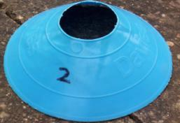
- 2 with number 4 (pts)

- Answer sheet only for YOU!

Preparation:
You need to design 15 maps which are all different so that 30 children can undertake the activity. Each map will only require children to visit and collect the point value of 12 cones (12 out of 14)
These Maps only show the cones position and Letter – NOT POINTS
Rules:
Children must travel along the lines using them as a guide to find the cones that are on their map only. There are 14 Cones in all – but each Map should only have 12 on it. This allows for variation of points, also to check that they are using the right cones as indicated by the map.
Put out the cones on a netball court as per the diagram, taking care to position them accurately.
F
 |  |  |  |  |  | Answer Sheet
 |  | 3 |  | 2 | 4
 |  |  |  |  |  | (The value given to
3 |  |  |  |  |  | each letter)
2
A,G,F,L = 1
B,C,E,K = 2
D,J,M,P = 3
H,N = 4
 |  | M |  | K | N
2
 | 1 | 1 |  |  | 1  C
J
E | A | G |  | L
 |  | 4 |  |  | 2
 |  |  |  |  |  | 3
1 |  |  | 3 | B
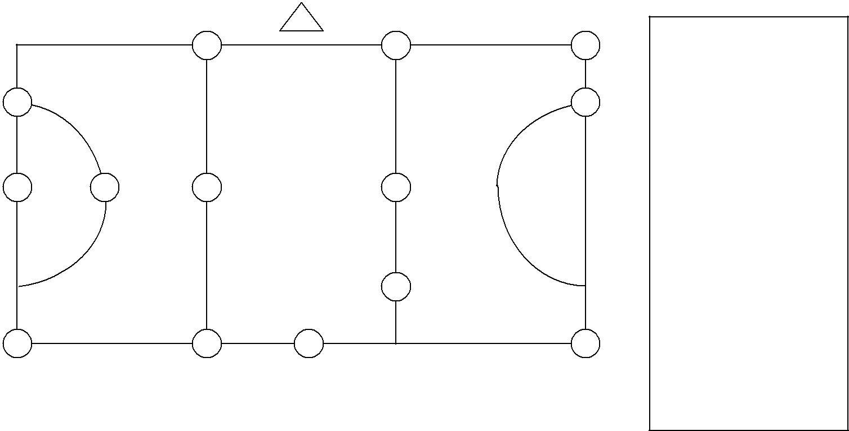
H  D | P

The Session:
- The children should be in pairs

- Explain that the triangle on the map represents the start.

- Give each pair a map (laminated) and suitable pen

- Remember to follow along lines and orientate the map to get the right Letter Cone and Points
Example: M, K, N, C, P, B, L, D, H, F, E, J = 30 points (is this the highest scoring route?)

