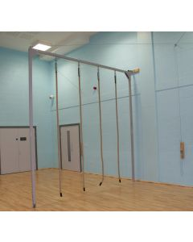Gymnastics Curricular Apparatus *– an audit*

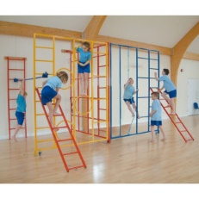

**Ropes:**

These are well worth considering and offer a wide range of possibilities and benefits. Tracking systems or pull-out frames can be fitted. Ask a supplier to conduct a site visit and advise / quote.

**Wall Bars:**

There are varying types and a reputable company will offer a site visit and a range of options. Wall bars that offer a wider range of movement opportunities / possibilities are worth investing in.

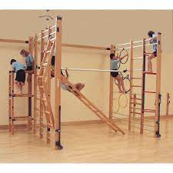

**Mats:**

Ensure enough for 1 mat / 2 pupils.

* 6 x 4
* 4 x 3

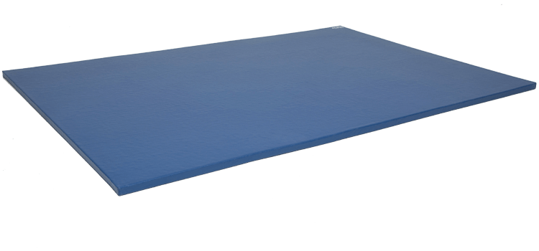

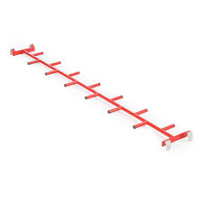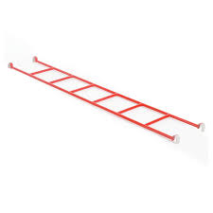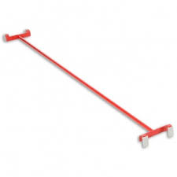

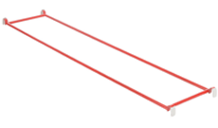

**Linking / Bridging Apparatus:**

These can add greater impact to apparatus such as Trestles and the Wall-frames by linking and bridging. The Pole provides rotation possibilities, ladders etc. climbing, hanging and supporting body weight. Make sure you consider accessibility and storage too.

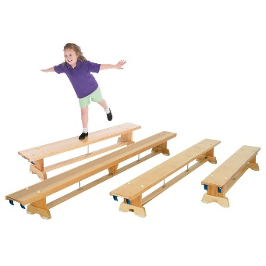

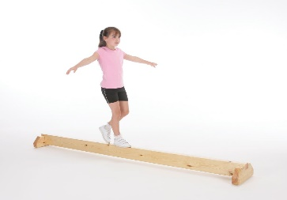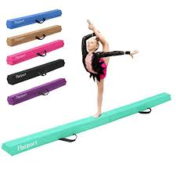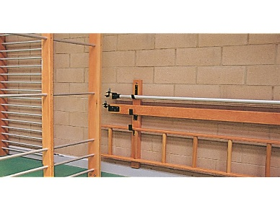

**Balance ‘Bar’:**

Wooden / metal balance bar to support pupils developing sense of stability, challenge etc. Can be a folding foam bar as in photo. Cheaper, easy to move and store

**Stowage:**

Wall hooks to make equipment accessible and safely stowed

**Benches:**

The basic unit of apparatus and challenge. Recommend:-

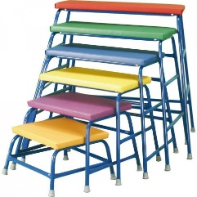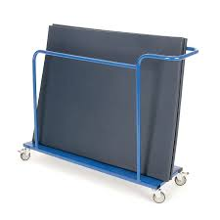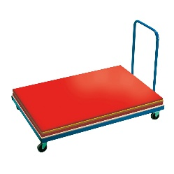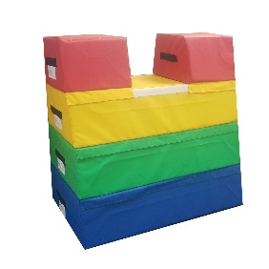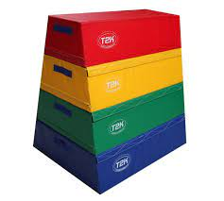

**Vertical Mat Trolley:**

Use when space is a premium.

**Flat Mat Trolley:**

Stores all Mats and allows pupils greater independence when carrying and setting out apparatus.

**Foam Vaulting Box:**

Modern alternative to ‘Horse’. Fixes using Velcro. Light and adaptable for inclusion. Also has vaulting through hand toppers to encourage pupils.

**Nesting Trestles:**

The basic platform for increasing activity, challenge, variety etc.