Rock, Paper, Scissors!
Teacher:
This initial activity can be played using hoops, patio slabs, even tyres. Feel free to adapt to suit your pupils, your resources and needs!
An Initial ‘Warm-up Activity’
Set up the agility ladder as shown
- Teams start at opposite ends facing each other
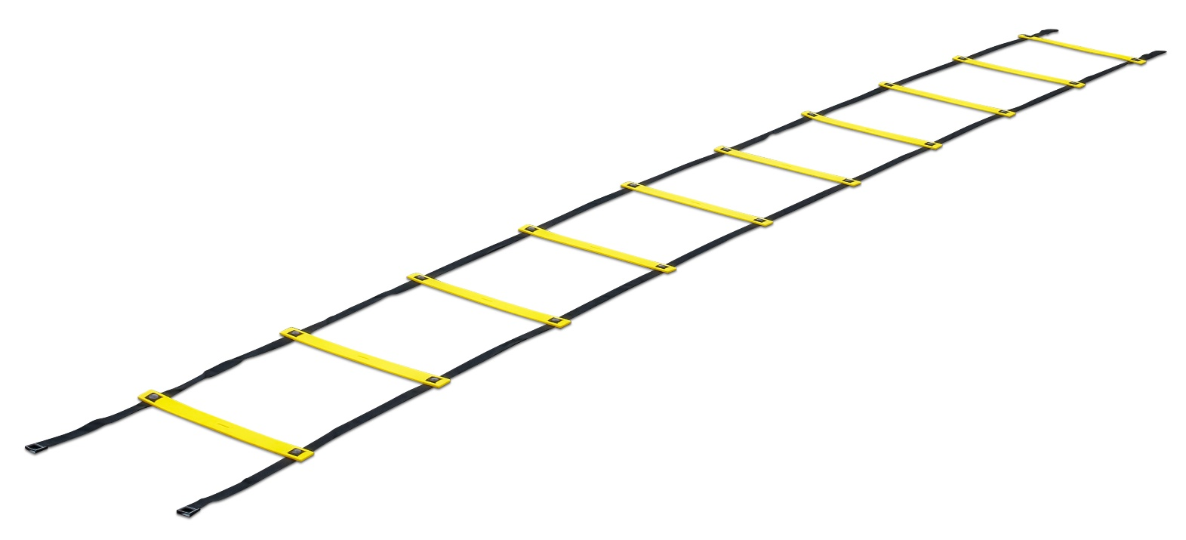
- Keep teams small, e.g. 4 max.
- You can use hoops, throw down spots, tyres etc.
Blues Direction of Travel
To Play:
- The first person from each team runs out and high steps through the ladder to the Centre Square which they leave empty
- Players then Rock, Paper, Scissors for the Centre Square
- Winner steps forward and occupies the Centre Square
- Loser exits ladders so new player from their team can high step up the ladder quickly to face the Winner
- Winner always stays in the ladder and STEPS FORWARD ONE Square - the loser always leaves and re-joins team
- Can YOUR Team travel through to the other side!
CENTRE
SQUARE

Reds Direction of Travel

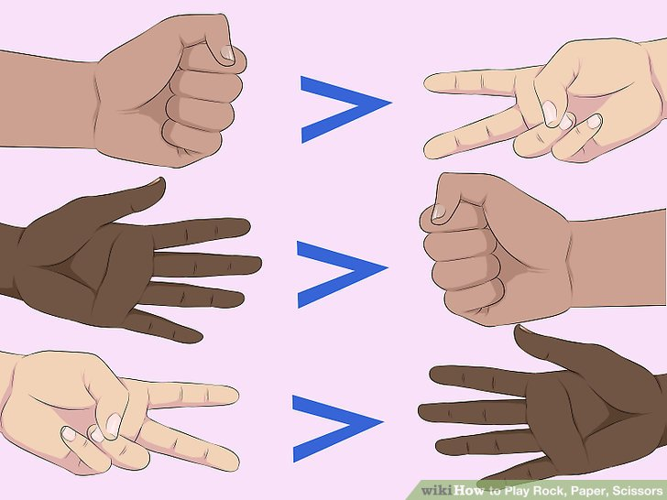
Beats

Beats

Beats

