
Gymnastic Resource Cards
Top Tip!

- Lean away slowly
- Let arms take the weight
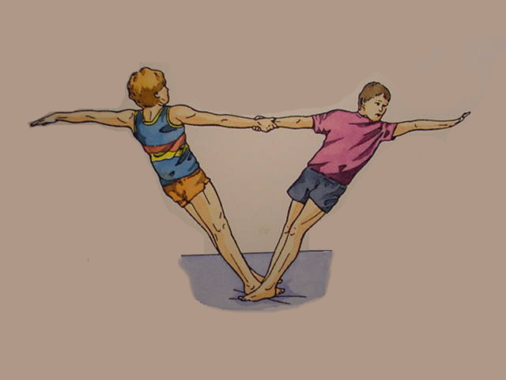
Counter-balance
Key Point
- Use each others body weight

- Feel the tightness in your body – core strong

- Hold the balance for 3 - 5 seconds

Think:

- How could you both get out of this position?

- How could you both get into it?

- Practice so that this flows smoothly
3
Twisted position
Right hand to right hand
Matching

