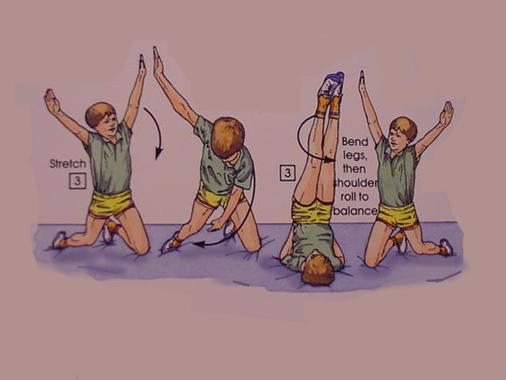

Gymnastic Resource Cards
Rolling
A simple individual rolling action involving a change of direction.
3
3
3
Hold the balance position for 3 seconds where you see this sign.
Key question: Can you perform some parts of the movement at different speeds?
Can you still show control and co-ordination?
Look at the stretched, straight legs – try to copy.
Look at the stretched, straight arms, try to copy
Extension activity:
When in the shoulder stand, vary the leg positions eg open. One bent one stretched etc.
3

