Gymnastic Resource Cards

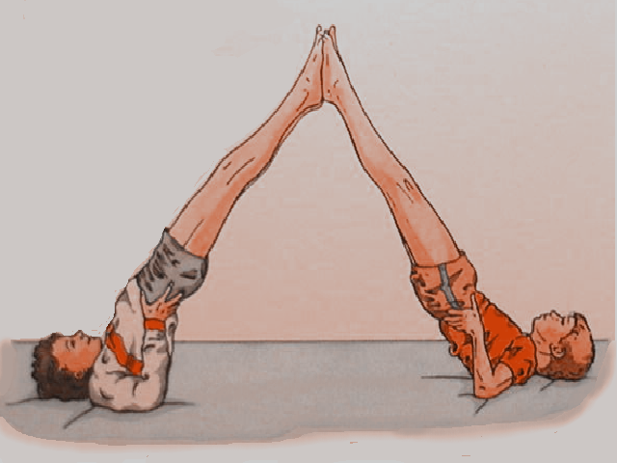
Counter Tension
Key Point
- Keep your body straight

- Keep your legs straight

Think:

- How could you get out of this position?

- How could you get into it?
Hands can brace behind your back to help hold you

