
Gymnastic Resource Cards

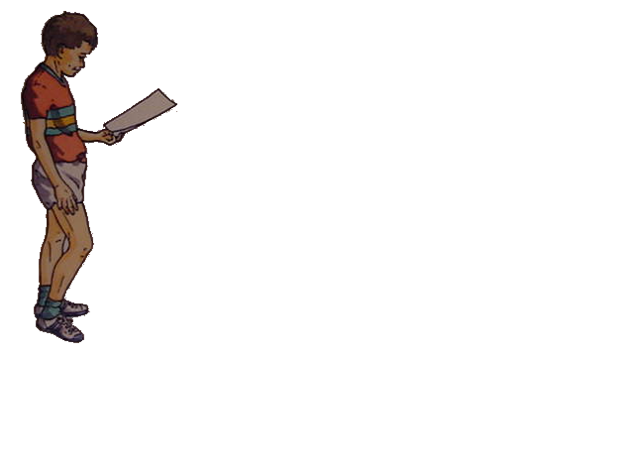
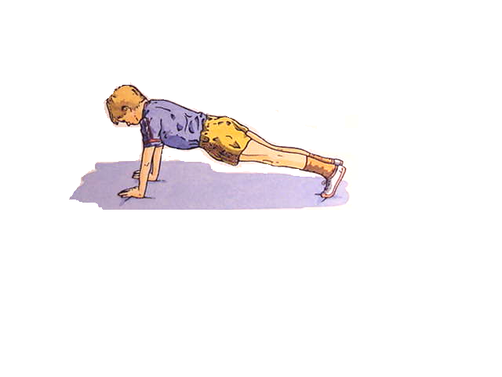
Front Support
Key Point
- Keep your body straight – core tight and tensed

- Keep your arms straight, hands under shoulder

- Shoulder, hip, knee and ankle all in line

Think:

- How could you get out of this position?

- How could you get into it?

- Can you ‘roll’ out of it in any way?

