Name  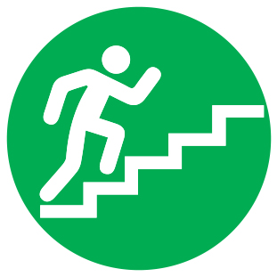  Gymnastics Challenge | Balance 1 | Balance 2 | Balance 3 | Balance 4 | Total
 | Easy | Medium | Hard | Expert

