Subject content - Key stage 1: Pupils should develop fundamental movement skills, become increasingly competent and confident and access a broad range of opportunities to extend their agility, balance and coordination, individually and with others. They should be able to engage in competitive (both against self and against others) and co-operative physical activities, in a range of increasingly challenging situations.

Pupils should be taught to: master basic movements including running, jumping, throwing and catching, as well as developing balance, agility and co-ordination, and begin to apply these in a range of activities; participate in team games, developing simple tactics for attacking and defending; perform dances using simple movement patterns.

What might the Learning Outcomes be for KS1 in Gymnastics?
Uses space safely & well Can remember, repeat & explore simple actions
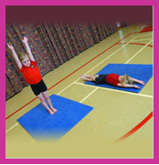
Can work cooperatively with a partner Work on apparatus safely
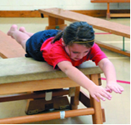
Can demonstrate different Levels in actions Can demonstrate differences in Speed
Can land safely when Jumping Can take weight on hands
Can create & apply different Body Shapes Can Balance on small and large body parts
Can Travel on different body parts Can Co-ordinate body during movements
Link movements to suit activity Can adapt ‘sequence’ to include apparatus
Is willing to practice and improve Can evaluate their own movements
Can say how their bodies feel during exercise

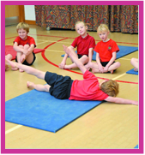
Help children evaluate and improve their performance by asking them:
• What actions are included in your sequence?
• Do you perform it smoothly and with control?
• What one thing do you think you could improve about your sequence?
• How would you go about improving this?

