**Subject content – Key stage 2:** *Pupils should* ***continue to apply*** *and* ***develop a broader range of skills****,* ***learning how to use them in different ways*** *and* ***to link them to make actions and sequences of movement****. They should* ***enjoy communicating, collaborating*** *and competing with each other. They should develop an* ***understanding of how to improve in different physical activities and sports*** *and learn how to* ***evaluate and recognise their own success****.*

**Pupils should be taught to:** *use* ***running, jumping****, throwing and catching in isolation and in combination; play competitive games, modified where appropriate [for example, badminton, basketball, cricket, football, hockey, netball, rounders and tennis], and apply basic principles suitable for attacking and defending;* ***develop flexibility, strength, technique, control and balance*** *[for example, through athletics and gymnastics]; perform dances using a range of movement patterns; take part in outdoor and adventurous activity challenges both individually and within a team;* ***compare their performances with previous ones and demonstrate improvement to achieve their personal best****.*

**What might the Learning Outcomes be for Gymnastics by the End of KS2?**

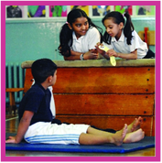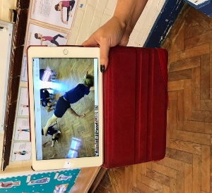

|  |
| --- |
| **Compose longer**, more **complex** sequences with partner/group Have **confidence & competence** to try new actions e.g. sportsacro |
| Include a wide range of **Actions, Body-shapes** and **Balances** Develop **Clear, Fluent and accurate movements** |
| Show **Consistency & Control** in their own movements Combine gymnastic ***actions, shapes and balances*** |
| Solve a task by applying a range of ***compositional ideas*** Perform a ***practised sequence*** to an audience in small groups |
| Can demonstrate control in a variety of **Pair Balances** Use ***Apparatus*** to support ***more challenging actions*** with **Control** |
| Be aware of ***factors that influence the quality*** of a performance Suggest aspects of a performance that need ***improving*** |
| Judge a performance using their own ***set of agreed criteria*** Say why it is important to **warm up and cool down** |
| Say why ***activity is good*** for their ***health and well-being*** |

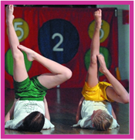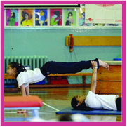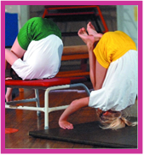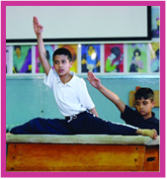

**Top Tips:** Use ‘***Performance Partners’*** – another pair to regularly show and share pupil progress with – evaluate & suggest improvements

***Use ICT*** as a tool to facilitate improvements in quality, poise, performance

**Key Vocabulary:** *Practise Control Consistency* ***Direction*** *Improve Fluent Link Confidence Quality Challenge Adapt* ***Levels*** ***Space******Extend*** *Complex Compositional Ideas Accurate* ***Speed*** ***Relationships Tension***